Copula-Based Modeling of Temperature-Precipitation Dependencies in Växjö, Sweden: Analysis and Climate Change Implications.
Chapters:
Abstract
Chapter 1:Introduction
1.1: Background and Context
1.2: Purpose and Research Questions
Chapter 2- Methodology
2.1: Data Collection and Pre-processing
2.1.1: Data Cleansing and Quality Control Techniques
2.1.2: Variable Selection and Transformation Procedures
2.1.3. Handling of Missing Values and Outliers
2.2: Statistical Analysis Framework
2.2.1: Descriptive Statistics Approach
2.2.2: Normality Testing Approach
2.2.3: Data Visualization Techniques
2.2.4: Seasonal Decomposition
2.3: Dependence Analysis
2.3.1: Kendall’s Tau Correlation Analysis
2.3.2: Seasonal Correlation Assessment
2.3.3:Temperature Value at Risk (T-VaR) and Expected Shortfall (T-ES)
2.3.4: Interpretation of Dependency Measures
2.4: Extreme Value Theory Application
2.4.1: Peak Over Threshold Method (POTM)
2.4.2: Generalized Pareto Distribution (GDP)
2.4.3: Return level and return period
2.4.4: Risk Measures for Temperature Extremes
2.5: Time Series Modeling
2.5.1: SARIMA Modeling for Temperature Forecasting
2.5.2: Hyperparameter Optimization Techniques
2.5.3: Model Validation and Error Analysis
2.5.3: Model Validation and Error Analysis
2.5.4: Forecasting Procedures and Evaluation Metrics
2.6: Copula Modeling Framework
2.6.1: Theoretical Foundation and Mathematical Background
2.6.2: Marginal Distribution Fitting
2.6.3: Clayton-Gumbel Mixture Copula Approach
2.6.4: Parameter Estimation Methods
2.6.5: Model Comparison Criteria
2.7: Hypothesis Testing Framework
2.7.1: Formulation of Null and Alternative Hypotheses
2.7.2: Statistical Methods for Hypothesis Testing
2.7.3: Correlation Measures Analysis
2.7.4: Testing Procedures for seasonal Variation
2.7.5: Comparative Analysis Methodology for Model Evaluation
2.7.6: Anova and Chi-Square Testing Approches
2.7.7: Bootstrap Methods for Confidence Intervals

Chapter 3: Results

3.1: Descriptive Statistics
3.1.1: Precipitation Patterns (Zero Inflation and Skewness)
3.1.2: Seasonal Patterns and Long-Term Trends
3.1.3: Data Transformation Outcomes
3.2: Dependence Structure Analysis
3.2.1: Overall Temperature-Precipitation Association
3.2.2: Seasonal Dependency Variations
3.2.3: Factors Influencing Dependency Strength
3.2.4: Visualizing Dependency Patterns
3.3: Time series Modelling Results
3.3.1: SARIMA Model Performance
3.3.2: Temperature Forecasting Accuracy
3.3.3: Seasonal Trend Predictions
3.3.4: Residual Analysis and Model Diagnostics
3.4: Copula Modeling Results
3.41: Marginal Distribution Fitting Findings
3.4.2: Single vs. Mixture Copula
3.4.3: Model Validation and Goodness of Fit
3.4.4: Simulation Performance and synthetic Data Generation
3.4.5: Synthetic Data & Simulation Results
3.5: Hypothesis Test Results
3.5.1: Correlation Test Results
3.5.2: Chi-square Test for Heterogeneity in Correlations
3.5.3: Pairwise Seasonal Comparisons
3.5.4: Statistical Significance of improvements
3.6: Climate Change Scenario Analysis
3.6.1: Baseline vs. Warming Scenarios(+2⁰C)
3.6.2: Predicted Changes in Extreme Events
3.6.3: Precipitation Response to Temperature Changes
3.6.4: Seasonal Pattern Shifts Under Different Scenarios

Chapter 4: Discussion
4.1: Interpreting Statistical Results
4.1.1: Bimodal Temperature Distribution
4.1.2: Zero-Inflation Trend in Precipitation
4.1.3: Weak overall Dependence with Seasonal Variability
4.1.4: Implications for Understanding Local Climate
4.2: Climate Modeling Insights
4.2.1: Advantages of the Mixed Copula Approach
4.2.2: Capture Complex Dependence Structures
4.2.3: Model Limits and Uncertainties
4.3: Implications of Hypothesis Testing
4.3.1: Interpretation of Rejected and Accepted Hypothesis
4.3.2: The Significance of Seasonal variations
4.3.3: Practical Implications of Statistical Results
4.3.4: Robustness of Results Using Multiple Testing Methods
4.3.5: Contextualizing Findings in Climate Science Literature
4.4: Climate Change Implications
4.4.1: Predicted Increase in hot days and decrease in Cold days
4.4.2: Precipitation Patterns and Extremes
4.4.3: Influence on Seasonal Climate Parameters
4.4.4: Regional Climate Vulnerability Assessment
4.5: Practical Applications
4.5.1: Agricultural Planning Recommendations
4.5.2: Water Resource Management Implications
4.5.3: Urban Planning and Sustainability Considerations
4.5.4: Climate Adaptation Strategies in Växjö

Chapter 5: Conclusion
5.1: Summary of key Findings
5.1.1: Results of Hypothesis Testing
5.1.2: Climate Change Projection Highlights
5.2: Research Contributions
5.2.1: Practical Application of Research Findings
5.2.2: Contribution to Climate Adaptation Knowledge
5.2.3: Prospective Research Directions

Chapter 6: Conclusion

Flowchart
Appendix
Reference

Abstract
Understanding the interrelationship between the temperature and precipitation interrelationship is crucial for improving regional weather forecasts, risk assessment, and adaptation planning. This study looks at the relationship between temperature and precipitation in Växjö, Sweden. It is based on 30 years of hourly weather data (1995-2024) and monthly records (2000-2024). The study employs advanced statistical techniques known as copula-based modeling, which go beyond the methods previously utilized in standard linear correlation investigations. This method can help describe the complicated, non-linear, and possibly asymmetric interrelations between these climate parameters, particularly the extreme values.
The most significant conclusion of this study is the development of a new mixture copula model. This novel model combines two distinct types—Clayton and Gumbel—to better reflect varied climate patterns, particularly those characterized by cold and dry vs warm and rainy circumstances. Furthermore, the study uses extreme value theory and a metric called Temperature Value-at-Risk (T-VaR) to determine the frequency and severity of uncommon, extreme temperature events.

SARIMA's time series modelling allows for more accurate temperature predictions. The strongest model I discovered, SARIMA(1,1,1)(1,0,1), does an excellent job of detecting daily and seasonal temperature changes. When we projected future climate change scenarios, I discovered an increase in the number of rainy and warm periods, as well as changes in precipitation patterns. This will create new issues for agriculture, water supply management, and infrastructure in Växjö.
This thesis proposes a novel statistical framework with both scientific and practical applications. It is based on copula modeling for Nordic climates, addresses seasonal changes in how temperature and precipitation interact, and provides practical suggestions for adapting to climate change. The findings are relevant for regional leaders because we provide a modeling tool that may be applied in other mid-latitude areas experiencing similar climate change.

Chapter 1:Introduction
Forecasting is the evaluation or forecast of future events based on comparisons to previous patterns, whether kept and preserved in human memory or accessed through other methods. Forecasting in climatology is very important since it has a direct impact on farm planning, urban growth, resource management, and catastrophe avoidance measures.
Temperature is one of the climate factors that has a complex interrelationship with precipitation that varies by region, altitude, and time scale. The goal of this research is to create and evaluate advanced statistical model representations that can preserve the joint response behavior of these key climate variables.

Conventional statistical methods for analyzing climate data have primarily relied on linear correlation measures and normal distribution assumptions. The nature of these qualities goes beyond previous modeling methodologies that can accurately simulate the nature of interacting climate factors.
To overcome these limitations, which are inherent in employing numerous univariate models, the current study employs copula-based statistical modeling approaches, which provide a strong mathematical framework specifically built for modeling multivariate dependencies. Temperature data has a distinct bimodal distribution that corresponds to daily and nighttime cycles, however precipitation has a substantially zero-inflated distribution with significant positive skew, which most multivariate approaches cannot handle concurrently.
Recent discoveries in climate research demonstrate how beneficial copula-based approaches may be in a variety of applications. For example, Schölzel and Friederichs (2008) used similar techniques to study how temperature and precipitation interact in Central Europe. Their research indicated that the way these elements interact is not equal—it is unbalanced, and this pattern varies throughout the year. Surprisingly, these findings appear to correspond with some preliminary results from climatic data in Växjö.
Even while this research has made tremendous progress, there is still a noticeable gap in our understanding, particularly when it comes to applying more advanced copula structures to anticipate climate variables in Nordic areas. This missing aspect is critically important to resolve, particularly in areas such as southern Sweden. These regions have such distinct climate traits, including significant seasonal fluctuations, that they may respond differently to the effects of climate change.
This study fills a gap in our understanding by developing a novel mixed copula model that combines Clayton and Gumbel components. This approach aims to better capture the link between temperature and precipitation in Växjö. By altering the importance of these components, the model provides a more detailed representation of the intricate interactions between temperature and precipitation at different levels.
The study focuses on five primary goals that aim to improve both the methodology utilized and the real-world applications of climate science. Finally, the study predicts how temperature and precipitation patterns may alter under various global warming scenarios. This provides vital insight into how climate change may affect the relationship between these two variables in the future and seasons.
This extensive investigation provides vital insights into Växjö's intricate weather patterns. It also lays a robust statistical foundation that can be adjusted and expanded to various regions. These discoveries improve both our theoretical understanding of climate systems and the practical application of this knowledge to real-world difficulties in our uncertain environment.
  - Background and Context
Temperature-precipitation correlations are among the most important interactions in climate dynamics, influencing environmental systems, water resource management, agricultural productivity, and regional economic growth. This project's goal is to develop accurate temperature forecasting methods, improve understanding of seasonal patterns and variations, and provide actionable insights to support better planning for both commercial enterprises and agricultural activities in the region by conducting a systematic examination of comprehensive climate monthly and hourly data from 2000 to 2024 and 1995 to 2024, respectively.
Växjö Kommun, located in southern Sweden, is an especially interesting subject in climate studies due to its location and peculiar weather patterns. The area's maritime effect helps to keep temperature swings under control, but it also complicates how precipitation behaves, particularly during the seasons when the weather changes.
Växjö's variable rainfall and winter snowfall present significant obstacles for farming and sustaining local infrastructure. These climate-related challenges underline the critical importance of accurate weather forecasting for climate-sensitive enterprises. Good forecasts are critical for guaranteeing long-term economic stability, sensible resource allocation, and avoiding the disruption that changing weather conditions can cause to production plans and supply chains.
Previous research has emphasized the need of understanding temperature-precipitation relationships across the world's many climate zones. These studies have shown that Copula-based methodologies have considerable advantages in modeling climate variable relationships across diverse ecosystems, ranging from dry regions to temperate zones.
Despite the rising body of international research, there is a considerable gap in the scientific literature about the application of sophisticated statistical models, particularly Copula-based methodologies, to the specific climatic conditions of Växjö Kommun and other Nordic locations. This research gap limits our capacity to generate realistic climate projections tailored to the region's specific needs, as well as develop effective climate adaptation measures for local agricultural and commercial interests.

This study employs Copula analytic tools to develop comprehensive models of the link between temperature and precipitation in Växjö Kommun, with the goal of closing a significant knowledge gap. This methodological upgrade will allow for more precise temperature projections for the area, taking into account how precipitation patterns influence temperature dynamics throughout different seasons and conditions.
The research findings, which include rigorous statistical analysis and modeling, will help Kronoberg County enhance its climate modeling capabilities, providing critical information for efficient resource management and the creation of effective responses to climate variability. Similarly, commercial businesses that rely on weather conditions, such as tourism, energy utilities, and transportation services, may profit from these insights in their operational planning and risk management strategies.

Växjö has a moderate climate, which is mainly influenced by air masses flowing from the Baltic Sea. This results in a unique weather pattern that necessitates certain modeling techniques. The non-parametric technique is ideal for examining consistent relationships between variables without making any assumptions about their underlying patterns. This is a significant advantage when working with climate data, which frequently contains uneven distributions, many zero values, and shifts with the seasons.
The ultimate purpose of this complete climate analysis is to provide actual benefits to regional stakeholders, rather than just academic research. These findings will help to inform decision-making in a variety of sectors, including agricultural production, water management, urban planning, and infrastructure development, thereby improving the region's ability to adapt to both current climate challenges and potential future changes in temperature-precipitation patterns.

  - Purpose and Research Questions
- Purpose of the study
This work develops cutting-edge statistical models with copulas to better explain the complicated, non-linear relationships between temperature and rainfall in Växjö, Sweden. The study examines 30 years of hourly weather data to identify seasonal changes, trends, and unexpected weather patterns that have a substantial impact on local farming—such as dairy, forestry, and cold-tolerant crops—as well as infrastructure maintenance during snowy periods. The models accomplish this by discriminating between individual weather behaviors and how they connect to one another, resulting in more accurate predictions than prior methods. The findings will help to plan for climate change by offering useful tools for forecasting temperatures, researching seasonal weather, and defining sustainable agricultural and environmental practices in Växjö.
- Research Questions

To accomplish these goals, this study answers the following research questions:
1. To know the statistical distribution of temperature and precipitation in Växjö?
- How do descriptive statistics like mean, variance, and skewness represent climatic data?
- Do temperature and precipitation have normal distributions? What adjustments can improve their statistical handling?
- How do data visualization approaches improve our understanding of climatic patterns?

2. How can we adequately represent the intricate relationship between temperature and precipitation?
- Is a single copula sufficient, or does a combination of copulas better represent the relationship?
- How do Clayton copulas (for lower tail reliance) and Gumbel copulas (for upper tail behavior) help create an accurate model?
- Can Sklar's Theorem help break down the joint distribution into manageable components?
3. How do temperature-precipitation correlations change with seasons?
- What are the seasonal patterns in temperature and precipitation data?
- Does the statistical dependency between variables vary greatly by season?
- How might seasonal decomposition improve climate forecast accuracy?
4. Describe temperature changes and extreme events in Växjö.
- How does Extreme Value Theory help grasp the risk of temperature changes?
- What measures are most effective for capturing temperature stress events (T-VaR, T-ES)?
- How well do SARIMA models capture hourly temperature cycles?
5. How may climate patterns change with different warming scenarios?
- How might a +2°C warming scenario affect precipitation patterns and seasonal distributions?
- How do variations in precipitation impact temperature distributions?
- What impact do climate changes have on agricultural planning and water management?
- Hypotheses
This study tests several important hypotheses:
1. H₀: There is no substantial link between hourly temperature and precipitation.
H₁: There is a strong correlation between temperature and precipitation.
2. H₀₁: There is no seasonal change between temperature and precipitation. An alternative explanation is that the temperature-precipitation relationship varies seasonally.
3. H₀₂: Copula-based models do not outperform classic statistical methods for predicting temperature-precipitation relationships. Copula-based models provide greater modeling capabilities for climate variables.
4. Specified Mixture Hypothesis: A weighted combination of Clayton (47%) and Gumbel (53%) copulas will more accurately describe the temperature-precipitation relationship than any single copula model.

- Significance of the Study
This study goes beyond Växjö and contributes to broader climate science by building strong statistical frameworks for studying complicated meteorological interactions. Understanding how temperature and precipitation patterns interact and may change in the future allows for more efficient adaptation methods and resource allocation in the face of climate unpredictability.
1.3. Literature Review
- Previous Studies on Temperature-Precipitation Relationships
The link between temperature and precipitation has been a primary focus of climate study because to its significant consequences for water resources, agriculture, and ecosystem functioning This study provided an important baseline understanding of how various climate variables interact in temperate regions, while the conclusions cannot be easily extended to Nordic climates such as Växjö.
Dzupire et al. (2020) expanded on this research by using more complex statistical methods to model temperature-precipitation relationships in southern Africa. Their findings stressed the need of taking nonlinear correlations into account, since traditional correlation techniques frequently fail to reflect the underlying nature of climate variable interactions. This work provides methodological insights that are relevant to the current investigation, specifically considering the limitations of standard statistical approaches.
Trenberth and Shea (2005) investigated global temperature-precipitation correlations and discovered that, while negative correlations dominate in summer and warm regions (where water limitations and surface heating effects are prominent), positive correlations frequently prevail in winter and colder regions (where atmospheric dynamics play a greater role). This global viewpoint adds vital context to understanding Växjö's climate, which may have different seasonal dependency patterns than more frequently researched places.
Wu et al. (2013) studied how these interactions would evolve under future climate scenarios, observing that rising temperatures could disrupt known temperature-precipitation relationships, with substantial implications for water supplies and agricultural development. Their findings highlight the need of creating robust models that can account for changing climate dynamics.
Despite this substantial body of research, there is still a significant gap in understanding how temperature and precipitation interact in Nordic climates such as Växjö, where seasonal differences are pronounced and climate change impacts may manifest differently than in more extensively studied regions.
- Copula Analysis Applications in Climate Science
Copula-based modeling has emerged as an effective tool in climate science due to its ability to characterize connections between variables independent of their marginal distributions. They created more accurate drought indices using copula functions, which account for the joint behavior of numerous climate variables.
Genest and Favre (2007) developed a foundational paradigm for using copulas in hydrological modeling. This study revealed important insights into how different copula groups might represent different characteristics of climate variable relationships.
Schölzel and Friederichs (2008) investigated temperature-precipitation interactions in Central Europe using copula techniques. While the current work focuses on bivariate correlations, these methodological breakthroughs indicate future extensions to include additional climatic factors.
Despite these gains, few studies have focused on mixture copulas for simulating climatic factors in Nordic regions. The literature demonstrates a specific gap in understanding how different copula components may record diverse features of temperature-precipitation connections throughout seasons or temperature regimes.
- Research Gaps Identified and Current Study’s Contribution
Research Needs:- When it comes to the Geographic & Climate Context, areas like southern Sweden in the Nordic region don't get the attention they deserve, despite the fact that towns like Växjö have extremely distinct seasons, frigid winters, and consistent rainfall all year.
Methodologically, there is also a gap: most research uses only one form of statistical tool known as a copula, but integrating other ones (such as Clayton and Gumbel) has yet to be thoroughly studied.
Seasonal Dependency is another area that requires improvement. We don't have many research that look at how the relationship between temperature and rainfall changes with the seasons in Nordic climates, or how climate change may affect these associations.
Extreme Value Theory has also not been completely incorporated. There has been little study combining EVT (such as Temperature Value at Risk) with copula models to deal with both normal weather and extraordinary events.
Finally, many studies remain theoretical, with little practical applicability in fields such as agriculture and business.
Key contributions: -We created a Mixture Copula Approach, which included 47% Clayton and 53% Gumbel. This combination successfully captures both cold-dry and warm-wet dependencies, outperforming single copulas and improving model fit significantly (AIC increases).
Our seasonal analysis indicated significant changes depending on the time of year. Winter, for example, exhibits a high positive association between temperature and precipitation (τ = 0.515), while summer shows essentially no correlation (τ = -0.00654).
By combining copulas with SARIMA, we were able to improve temperature forecasting accuracy by accounting for both the correlations between variables and their trends across time.
Climate Change Scenarios predicted that warming by +2°C will significantly alter seasonal temperatures and have complex consequences on precipitation patterns.
These findings have practical applications for the Växjö region, providing significant insights into agriculture, water management, and business planning, as well as useful tools for adapting to climate change.
Impact: This work improves climate modeling by filling gaps, predicting extreme events, and applying methodologies to real-world applications in Växjö and beyond.
Chapter 2- Methodology
For my thesis, I collected two types of meteorological data from Växjö, Sweden: monthly aggregated data and hourly observationsThis dual-resolution approach enabled both comprehensive temporal forecasting and detailed statistical analysis of climate variable interdependencies.
2.1. Data Collection and Pre-processing
Data set Description:- The study employs a comprehensive 30-year dataset (1995-2024) of hourly meteorological measurements from Växjö, Sweden, totaling 253,684 observations. The primary dataset includes hourly temperature and precipitation readings, as well as monthly aggregated data from 2000 to 2024 for seasonal analysis. This thorough temporal coverage provides a solid platform for climate pattern research, with high-resolution hourly data allowing for deep exploration of diurnal cycles and monthly aggregations facilitating seasonal trend identification.
Data set Structure: Total hourly observations:-253,684-Training set size 202,947 observations-Test size 50,737 observations-Temperature range:-21.8ºC to 33.3ºC- Precipitation range- 0 to 26.5mm per hour-Zero precipitation:46.94
Table1:-Temperature statistics
Mean | Standard deviation | Variance
7,166ºC | 7.857803ºC | 46.78775

Table2:-Precipitation statistics
Mean | Standard deviation | Proportion of 0 values
0.07792mm per h | 0.4172314mm | 0.4694093

This extensive dataset provides robust foundation for both time series modeling and dependency analysis, capturing the full range of climate conditions experienced in Växjö over nearly three decades
2.1.1. Data Cleansing and Quality Control Techniques
Data quality was ensured by a systematic approach to outlier detection and management. The dataset had a large number (46.94%) of zero precipitation values, which were considered as valid meteorological conditions rather than missing data.

2.1.2. Variable Selection and Transformation Procedures
The study focused on temperature and precipitation as major variables, employing a variety of transformation strategies to address non-normality in the distributions. For temperature data that showed slight non-normality (Shapiro-Wilk W=0.9595, p-value=2.114e-07), the Box-Cox transformation (W=0.9427, p-value=0.007) was the most effective at normalizing the distribution.
Data rescaling for Time series analysis: For SARIMA modeling, data was rescaled using the min-max normalization: V_{i} = $\frac{a_{i}-min⁡(a_{i})}{\max\left(a_{i}\right)-min⁡(a_{i})}$
Where:-V_{i} is the rescaled value – a_{i} represents the original data – min (a_{i}) and max (a_{i}) are the minimum and maximum values of the original dataset.
The bimodal character of temperature was represented as a mixture of two normal distributions:
$F_{T}(t)=ω_{T}.Φ(\frac{t-μ_{1}}{σ_{1}})$+(1- $ω_{T}).Φ(\frac{t-μ_{2}}{σ_{2}})$
Where $ω_{T} and 1-$ $ω_{T}$are the weight of the first and second normal component. $μ_{1} \& μ_{2}$ are the mean of the first and second normal component and $σ_{1} \& σ_{2}$ are the standard deviation of the first and second component, $Φ$ is the cumulative distribution function of the standard normal distribution.
Table3:
Parameter Estimates | comp 1 | comp 2
Lambda or $ω$ | 0.5849189 | 0.4150811
Mu | 2.536623 | 13.95644
Sigma | 5.678263 | 5.19978
This bimodal structure reflects the distinct seasonal temperature regimes in Växjö, with the first component representing colder periods and the second capturing warmer conditions.

Precipitation Distribution Modeling: - To account for precipitation’s high non-normality (w=0.9244. p-value=3.443e-11) and significant right skewness(=1.264), a zero-inflated lognormal distribution was employed:
$F_{P}\left(p\right)=p_{0}$ If $p=0$
=$F_{L,N}$(p) if p>0
Where F_{L,N} is the lognormal distribution and $p_{0}$ is the probability of zero precipitation.The density function of F_{L,N} = $Φ(\frac{In(p)-μ}{σ}$)
Where p is the precipitation amount (strictly positive). $Φ$is the standard normal cumulative distribution function. $μ$ is the mean of the logarithm of precipitation (local parameter). $σ$is the standard deviation of the logarithm of precipitation (scale parameter).

Parameter Estimates:- Zero-inflation probability:-p₀=0.4694093
meanlog sdlog
-1.089467 1.050978
This approach effectively captured both the high frequency of dry periods and the right-skewed distribution of precipitation intensities when rain occurred.

2.1.3. Handling of Missing Values and Outliers
Missing values in the dataset were treated with a variety of strategies according to the data's temporal structure. The approach was designed to preserve the natural patterns in meteorological data while maintaining statistical integrity.
Category | Approach | Details
Temperature Data Imputation | Short gaps (≤3 hrs) | Linear interpolation:  Assumes near-linear change over short periods.
 | Medium gaps (3–24 hrs) | Weighted average using diurnal cycles. Estimates values from similar hours on adjacent days. Preserves daily temperature patterns
 | Long gaps (>24 hrs) | Seasonal averaging: uses equivalent hours from adjacent days in same season. Preserves seasonal variability while allowing day-to-day differences.
Precipitation Data Imputation | Conservative, zero-inflated method | Short gaps filled only if adjacent periods show precipitation. Proportion-based algorithms used to preserve total amounts and skewed distribution.
Outlier Treatment | Step 1: Statistical identification | IQR-based detection of extreme values.
 | Step 2: Meteorological verification | Cross-checked against regional events and historical records
 | Step 3: Physical plausibility | Ensured values fall within realistic local climate ranges
 | Step 4: Decision protocol | Systematic retention, adjustment, or exclusion based on evidence

2.2. Statistical Analysis Framework
2.2.1. Descriptive Statistics Approach:- A thorough set of descriptive statistics was used to characterize the central tendency, dispersion, and shape of the temperature and precipitation distributions in Växjö. These fundamental measures provided the foundation for under standing the data characteristics before applying advanced modeling techniques.:
Mean= x̄ = (∑x_{i})/n, x_{i} = individual values , n = number of observations
Variance=σ² = ∑(x_{i} - x̄)²/(n-1), Skewness=γ₁ = [n/((n-1)(n-2))] × ∑((x_{i} - x̄)/s)³, s=SD

Kurtosis=γ₂ = [n(n+1)/((n-1)(n-2)(n-3))] × ∑((x_{i} - x̄)/s)⁴ - [3(n-1)²/((n-2)(n-3))], s is the standard deviation.
Table4:-Interpretation Guidelines:-

Skewness:  - γ₁ = 0: Symmetric distribution  - γ₁ > 0: Right-skewed (positive skew)  - γ₁ < 0: Left-skewed (negative skew) | Kurtosis:  - γ₂ = 3: Normal distribution (mesokurtic)  - γ₂ > 3: Heavy tailed (leptokurtic)  - γ₂ < 3: Light-tailed (platykurtic)

Table5:-Results for Våxjö Climate Data
Variable | Mean | Variance | Skweness | Interpretation
Temperature | 7.526°C | 46.78775 | 0.09036287 | mild climate with mild swings; approximately symmetrical distribution, indicating balanced hot and cold seasons.
Precipitation | 57.786 mm | 1203.877 | 1.264644 | High variability with significant month-to-month fluctuations; right-skewed, indicating more frequent extreme rainfall events than very dry times.

In summary, the descriptive analysis shows that Växjö's temperature data is quite stable and balanced, but precipitation patterns are highly erratic and tend to swing to the extremes. These contrasting characteristics highlight the need for advanced, specialized modeling tools to accurately capture both the moderate temperature changes and the unusual, heavy-tailed behavior of precipitation.

2.2.2 . Normality Testing Approach:-The Shapiro-Wilk test was utilized to formally analyze whether temperature and precipitation data followed normal distributions. This assessment was crucial for determining appropriate statistical methods and transformation requirements. Shapiro-Wilk Test Statistic:-W= $\frac{({\sum{a_{i}x_{i})}}^{2}}{\sum{{( x_{i}-\overline{x})}^{2}}}$
where W = test statistic, x_{i} = ordered sample values, a_{i} = constants generated from means, variances, and covariances and x̄ = sample mean.
Hypothesis Framework:- Null Hypothesis (H₀): The data follows a normal distribution- Alternative Hypothesis (H₁): The data does not follow a normal distribution .
Decision Rule:-
• If p-value > α (0.05): Accept H₀ (data follows normal distribution)
• If p-value < α (0.05): Reject H₀ (data does not follow normal distribution)
Test Results:-
Temperature Data:- W-statistic = 0.9595- p-value = 2.114e-07.
Precipitation Data:-- W-statistic = 0.9244- p-value = 3.443e-11.
Conclusion: . Both p-values being significantly below 0.05 led to rejection of the null hypothesis, confirming that neither variable followed a normal distribution. This finding prompted the investigation of various transformation techniques to normalize data for parametric statistical methods, as well as the selection of appropriate non-parametric approaches for correlation analysis.
Transformation Analysis:- Given the non-normality, several transformation techniques were applied and evaluated: Box-Cox Transformation Results:- Temperature: W = 0.9427, p value = 0.007, skewness =-0.0078.
Precipitation: W = 0.9457, p-value = 0.009, skewness =-0.5212
The Box-Cox transformation provided the best normalization for temperature data, while square-root transformation was most effective for precipitation. However, none of the transformations achieved perfect normality (all p-values remained < 0.05), supporting the decision to use non-parametric methods such as Kendall’s tau for correlation analysis.
2.2.3. Data Visualization Techniques :-Data visualization played a crucial role in understanding the complex patterns and relationships within the Växjö climate data. Multiple visualization approaches were employed to reveal different aspects of the data structure and temporal patterns.
Histogram and Density Plot Analysis:-Histograms were constructed using optimal bin width determined by Sturges’ rule: k =⌈log₂n+1⌉ Where k is the number of bins and n is the sample size.
Key Findings from Temperature Visualizations:- Temperature distribution showed bimodal characteristics reflecting seasonal patterns- Peak around 15-20°C indicated higher frequency of warmer temperatures- Generally normal distribution with mild skewness confirmed moderate climate- No significant outliers, suggesting consistent temperature patterns .
Key Findings from Precipitation Visualizations:- Strong right-skewed distribution with peak around 40-50mm- Significant zero-inflation (46.94- Occasional extreme events (150-200mm) occurring less frequently- Box plots revealed numerous outliers representing extreme precipitation events
Time Series Analysis:- Time series plots revealed:- Clear seasonal temperature cycles ranging from-10°C to 20°C- Precipitation showing high variability with no clear long-term trend- Periodic patterns in both variables corresponding to annual cycles- Some extreme events, particularly in precipitation data .
Scatter Plot Analysis:-
Seasonal scatter plots with color-coding revealed:- Different temperature-precipitation relationships across seasons- Summer showing highest temperatures with variable precipitation- Winter displaying lowest temperatures with moderate precipitation- Spring and autumn serving as transitional periods .
Hexbin Mapping:- For the large hourly dataset, hexagonal binning was 6 employed to address overplotting issues. Density was calculated as: Density_{bin} = n_{bin} /A_{bin.} This visualization revealed:- Highest data concentration at zero precipitation and mild temperatures (0-20°C)- Uniform but sparse distribution of precipitation events across temperature ranges- Weak overall dependency between temperature and precipitation.

2.2.4. Seasonal Decomposition: - Seasonal decomposition was applied to extract and examine the systematic seasonal patterns in temperature and precipitation. This analysis was essential for understanding the temporal structure of Växjö’s climate and informing subsequent modeling approaches. The data was aggregated into meteorological seasons (winter, spring, summer, autumn) and analyzed using both descriptive statistics and formal decomposition approaches.
Monthly Aggregation process:-
Monthy mean temperature T_{y,m} is calculated as:
$T_{y,m}$=$\frac{1}{n_{y,m}}\sum_{i=1}^{n_{y,m}}{t_{y,m,i}}$ where $t_{y,m,i}$ is the i -th hourly temperature measurement in month m of year y. $n_{y,m}$ is the number of valid hourly observations in that month. ‘y’ element of {1995,1996….2023} represents the 30-year period and ‘m’ element of {1,2…12} represents the months. Next we calculate the climatological monthly data mean calculation- the long- term mean temperature for each month is :
${\overline{T}}_{m}$=$\frac{1}{30}\sum_{y=1995}^{2023}{T_{y,m}}$. These values define the threshold for anomaly coloring in the visualization.
The temperature anomaly determination A_{y,m}=T_{y,m}-${\overline{T}}_{m}$
In our visualization, when A_{y,m}$≥0$ bars are colored , and when A_{y,m}<0 bars are colored blue.
Moving average Analysis:- A 3-month centered moving average was applied to smooth short-term fluctuations. The 3-month centered moving average- the black line in our graph represents:
M A _{y,m} =$\frac{T_{y,m-1}+T_{y,m}+T_{y,m+1}}{3}$
Seasonal Statistics Summary
Season mean_temp mean_precip sd_temp sd_precip
1 Winter -0.87 41.8 1.1 9.3
2 Spring 6.21 44.8 1 10.7
3 Summer 15.6 82.3 0.98 24.0
4 Autumn 7.49 64.0 1.02 28.3
Key Seasonal Insights:- Clear temperature seasonality with summer being warmest (15.6°C) and winter coldest (-0.87°C)- Summer showing highest precipitation (82.3mm) with greatest variability (SD = 24.0mm)- Temperature variations relatively stable across seasons (SD 1°C)- Precipitation showing more variable patterns with autumn having highest variability (SD = 28.3mm).

2.3. Dependence Analysis
2.3.1. Kendall’s Tau Correlation Analysis:- To assess the relationship between temperature and
precipitation in Växjö, Kendall’s Tau correlation was employed due to its non-parametric nature and robustness to non-normal distributions identified in the previous analysis.
Mathematical Definition:- Kendall’s Tau ($τ$) is defined as:-

τ= $\frac{C-D}{\frac{1}{2}n(n-1)}$ , where:
- C = Number of concordant pairs=When higher temperature corresponds with higher precipitation
- D = Number of discordant pairs=When higher temperature corresponds with lower precipitation
- n = Total number of observations.
Concordance and Discordance:- A pair (x_{i}, y_{i}) and (x_{j}, y_{j}) is:
- Concordant if (x_{j}−x_{i})(y_{j}−y_{i})>0 (both increase or both decrease)
- Discordant if (x_{j}−x_{i})(y_{j}−y_{i})<0 (one increases while the other decreases)
Interpretation of τ:
- τ=1$≫$ Perfect positive correlation (all pairs are concordant)
- τ=−1$≫$Perfect negative correlation (all pairs are discordant)
- τ=0$≫$ No correlation
This approach is very helpful in climatology and environmental sciences, where data may not follow a linear pattern, because it may be used to analyze monotonic correlations.
Hypothesis are::
Hypothesis Null (H₀): -The relationship between temperature and precipitation is not monotonic; τ = 0 (tau = 0). Precipitation and temperature don't affect one another.
The alternative hypothesis (H₁) states that temperature and precipitation have a monotonic connection, that τ ≠ 0 (tau is not equal to zero), and that temperature and precipitation are interdependent.
Compute the test statistic-z score
Kendall’s tau follows an approximately normal distribution under the null hypothesis, for large samples (n>10),
σ_{τ}=$\sqrt{\frac{2(2n+5)}{9n(n-1)}}$
The test statistic is: Z=τ/σ_{τ}
Determine the p-value:-The p-value is obtained from the standard normal table: p=2×P(Z>∣Z_{obs}∣)
For a one-tailed test, use:p=P(Z>Z_{obs})
Decision rule
- If p≤α reject H_{0​} (there is a significant association).
- If p>α, accept H₀ (no significant association)
Test Results from our data: -
p-value = 6.291e-05 (far smaller than α = 0.05) - test statistic: z = 4.0016 &- tau = 0.3230626
The null hypothesis is rejected because the p-value (6.291e-05) is less than the α (0.05). This finding suggests that higher temperatures tend to be associated with higher precipitation in Växjö, though the relationship is not strong enough for precise prediction of one variable from the other.
2.3.2 Seasonal Correlation Assessment
To understand how the temperature-precipitation relationship varies through out the year, Kendall’s tau correlation was calculated separately for each metrological season. This analysis revealed substantial seasonal variations in dependency patterns.

Season kendall_tau n
<chr> <dbl> <int>
1 Autumn -0.191 18
2 Spring 0.433 18
3 Summer -0.00654 18
4 Winter 0.515 18
We looked at 18 observations from each season (using seasonal averages) to ensure that we could compare them fairly. After analyzing the data, we discovered that winter had the strongest positive correlation (τ = 0.515), implying that warmer winters bring more rain or snow. Spring also has a positive connection (τ = 0.433), albeit not as strong. Summer, on the other hand, displays absolutely no connection at all (τ = -0.00654), indicating that temperature and precipitation are not actually related there. In fall, we detect a modest negative connection (τ = -0.191), indicating that it may be slightly wetter when the weather is milder.

Statistical Significance Testing:- These seasonal variations represent statistically significant differences in the temperature-precipitation relationship, emphasizing the importance of seasonal considerations in climate modeling for Växjö, water resource management, and climate adaption measures.
2.3.3. Temperature Value at Risk (T-VaR) and Expected Shortfall (T-ES) :-To quantify the risk of extreme temperature variations, specialized risk metrics adapted from financial risk management were developed and applied to the Växjö temperature data.
a.Temperature return series
For the hourly temperature series, let {T_{t}} be a discrete-time stochastic process. The absolute temperature change, represented by the symbol ${∆T}_{t}$, can be found using:

Temperature return= ${∆T}_{t}=T_{t}-T_{t-1} (1)$
where:
- $T_{t}$ represents the temperature at time t (measured in degrees Celsius).
- $T_{t-1}$represents the temperature at the previous hour (t−1).
- ${∆T}_{t}$>0 $=≫$ a warming event
- ${∆T}_{t}$<0$=≫$ a cooling event.
b. Temperature stress measure
The temperature stress measure $X_{t}$ is defined as:
$X_{t}$=${-∆T}_{t}=$-($T_{t}-T_{t-1}$) (2)
where:
- X_{t}>0 indicates a cooling event (temperature drop).
- Xt<0 indicates a warming event (temperature rise).

Temperature Value at Risk (T-VaR)
The temperature value at risk (T-VaR) is defined at confidence level $α$:-
${T-VaR}_{α}$(X)= inf$\left\{xϵR:p\left(X_{t}>x\right)≤α\right\}$ (3)
where:
- α = confidence level (e.g., 0.05 for 95%).
- P(X_{t}>x) denotes the probability of observing a temperature stress event greater than x.
For a discrete sample $X_{(1)}<.......{<X}_{(n)}$ ​ (ordered statistics), the empirical estimate of T-VaR is:
${T-VaR}_{α}$=$X_{k}$ (4)
Where:
- k=⌈n(1−α)⌉ (ceiling function),
- n = number of observations,
- X_{(k)}=k^{-th} order statistic.
If k=n(1−α) is not an integer, T-VaR can be estimated using the formula of linear interpolation:
- T-VaR_{α}=λX_{(⌊k⌋)}+(1−λ)X_{(⌈k⌉)} ​
- where λ=k−⌊k⌋

Temperature Expected shortfall (T-ES)
The estimated magnitude of extreme temperature stress events that occur over the T-VaR threshold is measured by the Temperature estimated Shortfall (T-ES), also known as Conditional T-VaR:
T-ESα=E[X_{t}∣X_{t}>T-VaRα] (5) ​

T-ES is calculated as follows for a discrete empirical distribution:
T-ESα=$\frac{1}{m}\sum_{i=k}^{n}{X_{(i)}}$​ (6)
where:
- m=n−k+1= number of exceedances beyond T-VaRα.
Temperature finding are:-T-VaR and T-ES Results:
alpha T_VaR T_ES
1 0.01 2.3 3.155132
2 0.05 1.4 2.053812
3 0.10 1.0 1.653881

Important information regarding patterns of temperature change is revealed by analyzing hourly temperature data. This hierarchical pattern indicates that moderate temperature variations of 1-1.4°C are more prevalent in the dataset, but large temperature changes (>2.3°C) are uncommon.
Basic Temperature Change Statistics:- Mean change: 0.0000122°C (essentially zero)- Standard deviation: 0.905°C- Range: ±13°C
Interpretation:-The analysis reveals that hourly temperature changes in Växjö are generally moderate, with most variations falling within ±0.905°C. However, extreme temperature changes do occur:- In the most extreme 1- When such extreme events occur, the average temperature drop is 3.16°C- The near zero mean change indicates no systematic warming or cooling trend in hourly variations- Extreme changes of ±13°C represent rare outliers in the dataset.
2.3.4. Interpretation of Dependency Measures
Table6:- Temperature–Precipitation Dependency Analysis (Växjö)
Aspect | Findings
Overall Relationship  . | Strength: Statistically significant but weak dependency (τ = 0.323, p = 6.291e-05).  Direction: Positive – higher temperatures generally linked to more precipitation.  Practical significance: Relationship too weak for reliable prediction of one variable from the other
Seasonal Patterns | Winter: Strongest positive correlation (τ = 0.515) → pronounced coupling in cold months.  Spring: Moderate positive correlation (τ = 0.433).  Summer: Virtually no correlation (τ = -0.00654) → precipitation independent of temperature.  Autumn: Slight negative correlation (τ = -0.191).
Risk Assessment (T-VaR & T-ES) | Moderate daily variability: Most hourly changes within ±1°C.  Occasional extremes: Rare shifts up to ±13°C.  Predictable thresholds: Clear probability levels for different stress events.  Stable long-term patterns: Risk measures consistent over study period.
Implications for Climate Modeling | 1. Simple linear models are inadequate for Växjö.  2. Seasonal variation must be explicitly modeled.  3. Risk frameworks should include moderate but significant tail risks.  4. Different seasons may require distinct modeling approaches.

2.4. Extreme Value Theory Application
2.4.1. Peak Over Threshold Method (POTM):- The Peak Over Threshold Method was implemented to analyze extreme tem perature changes in Växjö by focusing on observations exceeding a statistically determined high threshold. This approach allows for detailed modeling of the tail behavior of temperature variations.
We define the exceedances above a high threshold u as follows given a series of temperature changes {X_{t}}:
Y=X−u/X>u
where:
- X denotes the temperature change.
- u is the threshold (usually used as the data's 95th percentile)
- X exceeds the threshold u by an excess amount, denoted by Y.
Threshold Selection:- The threshold selection balanced statistical requirements with practical considerations:- Statistical principle:- High enough to satisfy asymptotic validity of extreme value theory- Sample size consideration:- Low enough to provide sufficient exceedances for reliable estimation- Physical interpretation:- Meaningful in the context of temperature variations.
2.4.2.Generalized Pareto Distribution (GDP):-The exceedances identified through POTM were modeled using the General ized Pareto Distribution, which provides the theoretical foundation for extreme value analysis.The Generalized Pareto Distribution (GPD) is used to describe the excesses Y=X−u, when X > u.
The cumulative distribution function (CDF) of the GPD is:
F(y;σ,ξ)=$\left\{1-{\left(1+\frac{ξy}{σ}\right)}^{\frac{-1}{ξ}}\right.$ for $ξ≠0$, y$≥0,$ $1+\frac{ξy}{σ}$>0
=$\left\{1-exp(\frac{-y}{σ}\right.)$ for $ξ=0$, y$≥$0
- σ>0= scale parameter.
- $ξ$=shape parameter .
- ξ>0 → heavy-tailed distribution (Frechet type).
- ξ=0 → light-tailed (Exponential distribution).
- ξ<0→ bounded tail (Weibull type).
- y≥0 when ξ≥0 , and 0≤y≤−σ/ξ when ξ<0.
Maximum Likelihood Estimator
A statistical model's parameters can be estimated using the Maximum Likelihood Estimation (MLE) approach, which maximizes the likelihood function. The goal is to select parameter values that maximize the likelihood of the observed data.
Likelihood function
Let X₁,X₂,…,X_{n} be an independent and identically distributed (i.i.d.) random sample from a probability distribution with a probability density function (pdf) f(x;θ), where θ is the unknown parameter (vector of parameters) to be estimated.
The joint probability density function is also called the likelihood function of the sample :
L(θ)=f(X₁;θ)f(X₂;θ)…f(X_{n};θ)
L(θ)= $\prod_{i=1}^{n}{f(X_{i;}}θ)$
The likelihood of witnessing the provided data as a function of the unknown parameter θ is expressed by this function.
Equation (1) or equation (2), which optimizes the likelihood function, then provides the estimated parameters. The underlying distribution is frequently unknown and can be highly complex when working with real-time data. The pseudo-maximum likelihood approach is applied in these situations. The estimate of the parameters, $θ$, is achieved by maximizing a function that is connected to the log-likelihood, which is different from the maximum likelihood technique.
Parameter Estimates for Växjö Data:-
location scale shape
3.36857553 1.22611966 0.02762301

Model diagnostics:- AIC = 1267.95 , BIC = 1279.541 , Negative Log-Likelihood Value: 630.975

The positive but small shape parameter ( = 0.0276) indicates a slightly heavy-tailed distribution of the Frechet type, suggesting that extreme temperature changes, while rare, can be more severe than would be expected under a normal distribution.
2.4.3. Return level and return period :- Return Level and Period Estimation Return levels and periods provide practical interpretations of extreme value analysis by quantifying the magnitude of events expected to occur within specific time frames. This analysis is crucial for risk assessment and infrastructure planning.In a particular return time T, the value that is anticipated to be exceeded once is known as the return level. It's calculated as:
R_{T}=u+σ/ξ((λT)^{ξ}−1)
where:
- λ represents the exceedance rate:
λ= $\frac{Number of exceedances above u}{Total number of observations}$
- The return period, or T, is the anticipated number of observations prior to an R_{T}-sized event.
- σ and ξ are the GPD parameters estimated from data.
Probability of exceedance
The chance of exceeding x for every value x>u can be found using:
P(X>x)=P(X>u)P(X>x/X>u)
Applying the approximation of GPD:
P(X>x)=ζ_{u}[1+ξ(x−u)σ]−1/ξ
where:
- ζ_{u} indicates probability of exceeding the threshold u.
- ξ and σ are the GPD parameters.
Probability of exceeding 5°C: 0.2102
Probability of exceeding 7°C: 0.0455
Probability of exceeding 10°C: 0.0085

Summary Statistics of Monthly Maxima:
Min. 1st Qu. Median Mean 3rd Qu. Max.
1.100 2.975 3.900 4.106 4.825 13.000
Interpretation:- These results indicate that:- A 5°C temperature change occurs approximately once every 4.76 observation periods- A 7°C change occurs roughly once every 22 periods- A 10°C change is expected only once every 118 12 periods- The Frechet distribution effectively models both common variations and infrequent extreme events.
2.4.4. Risk Measures for Temperature Extremes
The integration of T-VaR analysis with extreme value theory provides a comprehensive framework for understanding temperature risks in Växjö. This synthesis offers both empirical and theoretical perspectives on extreme temper ature events.
Table7:-Risk Measures Comparison:
T-VaR Analysis | Fréchet Exceedance probabilities
99% T-VaR = 2.3°C (T-ES = 3.16°C) | P(X > 5°C) = 21.02%
95% T-VaR = 1.4°C (T-ES = 2.05°C) | P(X > 7°C) = 4.55%
90% T-VaR = 1.0°C (T-ES = 1.65°C) | P(X > 10°C) = 0.85%
A thorough grasp of temperature variation patterns can be obtained by combining the T-VaR and Fréchet distributions to analyze temperature changes. These exceedance probabilities show how consistent these approaches are with the T-VaR thresholds and offer a strong framework for comprehending both normal temperature variations and extreme events.
Our examination of the temperature trends in Växjö shows that the climate is largely constant with sporadic notable variations. With a 5% chance of temperature dips above 1.4°C and a 1% chance of reductions exceeding 2.3°C, the T-VaR study offers important information for assessing climate risk in Växjö.
To gain a clear understanding of the distribution and behavior of our data, we use various visualization techniques.
2.5. Time Series Modeling
2.5.1. SARIMA Modeling for Temperature Forecasting
Seasonal Autoregressive Integrated Moving Average (SARIMA) modeling was employed to capture both temporal dependencies and seasonal patterns in hourly temperature data. This approach acknowledges the strong daily and seasonal cycles characteristic of Växjö’s climate.
The hourly temperature data is anticipated using a Seasonal ARIMA (SARIMA) model. The seasonal difference can be used to predict data made 24 hours apart in the time series x_{t} since hourly temperature shows a daily seasonal pattern:
$$ϕ(B^{24})Δ_{24}^{D}x_{t}=θ(B^{24})α_{t}$$
Where,
- $Δ_{24}x_{t}=(1-B^{24})x_{t}=x_{t}-x_{t-24}$ and $ϕ\left(B^{24}\right)and θ(B^{24})$ represent seasonal differencing to remove daily cycles,
- $ϕ(B^{24})θ(B^{24})$ are polynomials in $B^{24}$ of order P and Q, respectively,
- α_{t​} is the error term, which is expected to be uncorrelated with the time series,
- Both polynomials satisfy the stationarity and invertibility conditions required for model stability.

Finally, The best forecasting model was chosen for this study using hyperparameter optimization. The SARIMA (p, d, q) × (P, D, Q)_{m} model requires the selection of six parameters:
Φ(B²⁴)ϕ(B)Δ¹Δ₂₄⁰ x_t = Θ(B²⁴)θ(B)α_t
Φ(B²⁴)ϕ(B)(1−B) x_t = Θ(B²⁴)θ(B)α_t
Where:
- ϕ(B) = (1 - φ₁B) — Regular AR(1) polynomial
- Φ(B²⁴) = (1 - Φ₁B²⁴) — Seasonal AR(1) polynomial
- Δ = (1−B) — Regular differencing operator (d=1)
- θ(B) = (1 - θ₁B) — Regular MA(1) polynomial
- Θ(B²⁴) = (1 - Θ₁B²⁴) — Seasonal MA(1) polynomial
- α_t — White noise error term
P stands for seasonal autoregressive order, D for seasonal differencing order, Q for seasonal moving average order, p for non-seasonal autoregressive order, d for non-seasonal differencing order, and q for non-seasonal moving average order.
Data Preprocessing:- Temperature data was rescaled using min-max normalization:
$$V_{i}=\frac{a_{i}-min(a_{i})}{max(a_{i})-min(a_{i})}$$
Where
- V_{i} is the rescaled value,
- a_{i} represents the original data,
This transformation stabilized variance and improved model convergence.
Model Identification:- The optimal SARIMA specification was identified as SARIMA(1,1,1)×(1,0,1)₂₄ through systematic evaluation of AIC values across different parameter combinations.
Final model equation= X_{t} = X_{t-1} + 0.576(X_{t-1} - X_{t-2}) + 0.9852(X_{t-24} - X_{t-25}) - 0.5675(X_{t-25} - X_{t-26}) + εt - 0.3831εt-1 - 0.8845εt-24 + 0.3388εt-25
Table8:-
Parameter | Estimate | Std.Error
Ar(1) | 0.0576 | 0.005
MA(1) | -0.3831 | 0.0055
Seasonal AR(1) | 0.9852 | 0.0005
Seasonal MA(1) | -08845 | 0.0014

The strong seasonal AR coefficient (0.9852) indicates high persistence in daily temperature patterns, while the seasonal MA component (-0.8845) captures the error dynamics of the daily cycle.
2.5.2. Hyperparameter Optimization Techniques
The model selection process involved systematic optimization using information theoretic criteria to identify the best-performing SARIMA specification.
Optimization Criterion:- The Akaike Information Criterion (AIC) was used as the primary selection criterion: AIC = −2ln(L) + 2k
Where:- L is the maximum likelihood of the model- k is the number of estimated parameters .
Grid Search Parameters:- The hyperparameter space was systematically explored:- Non-seasonal AR order (p): 0-3- Non-seasonal differencing (d): 0-2- Non-seasonal MA order (q): 0-3- Seasonal AR order (P): 0-2- Seasonal differencing (D): 0-1- Seasonal MA order (Q): 0-2 Model Selection Results:*The SARIMA(1,1,1)×(1,0,1) model achieved the lowest AIC value (-1,495,619), indicating superior fit among all candidate models.
Cross-Validation:-Model robustness was validated using time series cross validation:- Training period: 1995-08-01 to 2018-12-01- Testing period: 2018 12-01 to 2024-10-01- Walk-forward validation approach maintained temporal order.
2.5.3 Model Validation and Error Analysis
Comprehensive model validation was performed to assess the adequacy of the fitted SARIMA model and identify potential areas for improvement.
Ljung-Box Test for Residual Autocorrelation:- A time series model's residuals are tested for considerable autocorrelation using the Ljung-Box test.
Q=n(n+2)$\sum_{k=1}^{h}{\frac{\hat{{ρ2}_{k}}}{n-k}}$
Where:- n is the sample size- $\hat{ρ}$_{k} is the sample autocorrelation at lag k- h is the number of lags tested.
Test results:- p-value < 2.2e-16
Test Statistic (Q)= 18,279
Degrees of Freedom (df) = 44
Conclusion:- The residuals are independently distributed (i.e., no autocorrelation exists),since the p-value is so low, suggesting that there is still significant autocorrelation in the residuals. This implies that not all relationships in the time series data are adequately captured by the ARIMA(1,1,1)(1,0,1)[24] model.

Table9:-Model fit statistics
Metric | Value | Interpretation
Log-likelihood | 747814.6 | High likelihood indicates good fit
AIC | -1,495,619 lower AIC indicates a better fit | Better models
BIC | -1,495,567 | Penalizes complexity more than AIC
σ² | 0.0001611 very low, indicates a stable model | Very low error variance

Table10:-Training Set Error Measures
Metric | Value | Interpretation
Mean Error (ME) | -2.92e-07 very close to zero, indicating no strong bias | Near-Zero bias
Root Mean square Error (RMSE) | 0.0127 | Low prediction error
Mean Absolute Error (MAE) | 0.00845 | Good average accuracy
Mean Absolute Scaled Error (MASE) | 0.2137 (Indicating good accuracy compared to a naive model) | Superior to native forecasts

2.5.4 . Forecasting Procedures and Evaluation Metrics
The validated SARIMA model was employed to generate forecasts with ac companying uncertainty quantification through prediction intervals.
Forecast Generation:- Point forecasts were computed recursively:-
$\hat{X}$_{T+h/T}=E(${X_{T+h}}/{X_{T},X_{T-1,…..}X_{1})}$
Prediction intervals: Forecast uncertainty was qualified using prediction intervals:-
$\hat{X}$_{T+h/T}$±z_{α/2}\sqrt{V[e_{{T+h}/T}]}$
Where $z_{α/2}$ is the critical value from standard normal distribution and $\sqrt{V[e_{{T+h}/T}]}$ is the forecast error variance
Test set Performance
Mean Absolute Error (MAE): 3.58
Root Mean Square Error (RMSE): 3.9
Mean Absolute Percentage Error (MAPE): 28.42 %

Annual Performance Degradation:
year MSE RMSE MAE

2018 19.8 4.46 3.82
2019 49.4 7.03 5.96
3 2020 47.6 6.90 5.87
4 2021 83.2 9.12 7.51
5 2022 64.8 8.05 6.52
6 2023 68.8 8.29 7.05
7 2024 69.9 8.36 6.90

Average yearly increase in MSE:- 8.3389 .
This degradation pattern suggests potential non-stationarity in the climate system or limitations in the model’s ability to capture changing patterns.
Forecast Summary Statistics:- Minimum forecast value: 0.5396- Maximum forecast value: 0.6503- Mean forecast value: 0.5894- Forecast range reflects daily temperature cycles with peak around midday (0.6503) and minimum in early morning (0.5396).
2.6. Copula Modeling Framework
2.6.1. Theoretical Foundation and Mathematical Background
The copula modeling framework provides a flexible approach for modeling the joint distribution of temperature and precipitation while preserving their in dividual marginal behaviors. This methodology is grounded in Sklar’s theorem, which provides the theoretical foundation for separating marginal distributions from dependence structures.
Sklar’s Theorem:- The joint distribution of temperature (T) and precipitation (P) can be expressed using Sklar’s Theorem:
$F_{T,P}(t,p)$=C($F_{T}(t),F_{P}(p))$ where $F_{T,P}$ is the joint distribution, $F_{T}$ and $F_{P}$ are the marginal distributions, and C:[0,1]²$→$[0,1] is a copula function representing the dependence structure between the variables.
This decomposition allows modeling of marginal distributions and depen dence structure separately, providing significant flexibility when dealing with complex non-normal data such as temperature and precipitation in Växjö.
Advantages of Copula Approach: 1. Marginal flexibility: Each variable can follow its most appropriate distribution
2. Dependence modeling: Complex dependency structures can be captured independently
3. Extreme event modeling: Tail dependencies can be explicitly modeled
4. Simulation capability: Realistic synthetic data generation for scenario analysis

2.6.2 Marginal Distribution Fitting
Bimodal Temperature Distribution: Temperature exhibited distinct bimodal characteristics, modeled as a finite mixture of normal distributions:
$F_{T}(t)=ω_{T}.Φ(\frac{t-μ_{1}}{σ_{1}})$+(1- $ω_{T}).Φ(\frac{t-μ_{2}}{σ_{2}})$
Where $ω_{T} and 1-$ $ω_{T}$are the weight of the first and second normal component. $μ_{1} \& μ_{2}$ are the mean of the first and second normal component and $σ_{1} \& σ_{2}$ are the standard deviation of the first and second component, $Φ$ is the cumulative distribution function of the standard normal distribution.

Parameter estimates: comp 1 (cold regime) comp 2(warm regime)
lambda 0.5849189 0.4150811
mu 2.536623 13.95644
sigma 5.678263 5.19978
Model comparison:
Distribution AIC BIC LogLikelihood
1 single normal 1765870 1765891 -882932.9
2 mixture normal 1765870 1765891 -880277.7

The mixture model significantly improved fit, capturing the seasonal temperature regimes in Växjö.

Zero-Inflated Precipitation Distribution: Precipitation was modeled using a zero-inflated lognormal distribution:
$F_{P}\left(p\right)=p_{0}$ If $p=0$
=$F_{L,N}$(p) if p>0
Where F_{L,N} is the lognormal distribution function and $p_{0}$ is the probability of zero precipitation.The distribution function of F_{L,N} = $Φ(\frac{In(p)-μ}{σ}$)
Distribution Comparison for Non-zero Precipitation-
Distribution AIC BIC LogLikelihood
1 lnorm 23448.72 23465.40 -11722.36
2 weibull 32223.75 32240.43 -16109.87
3 gamma 33222.84 33239.52 -16609.42
4 exp 33340.94 33349.28 -16669.47

The lognormal distribution provided superior fit by all criteria.
Final Parameters:- Zero-inflation probability: p = 0.4694093
Lognormal parameters: meanlog =-1.089467, sdlog = 1.050978
2.6.3. Clayton-Gumbel Mixture Copula Approach
After determining that a single copula was insufficient to capture the complex dependency structure, a mixture of Clayton and Gumbel copulas was developed.
Mixture Copula Definition: C(u,v)=$ω$. $C_{clayton}(u,v;θ_{C})$+(1-$ω$).$C_{Gumbel}(u,v;θ_{G})$
The Clayton copula capures lower tail dependence(cold-dry relationship):
$$C_{Clayton}(u,v;θ_{C})= ({u^{-θ_{C}}+v^{-θ_{C}} -1)}^{-\frac{1}{θ_{C}}}$$
The Gumbel copula models upper tail dependence (warm-wet relationship):
$$C_{Gumbel}(u,v;θ_{G})=exp(-(({- In u)}^{θ_{G}}+(-{{In v)}^{θ_{G}})}^{1/{θ_{G}}})$$

Optimization Results: Clayton parameter: C = 0.2182647−Gumbelparameter :G= 1.001 – Mixture weight(Clayton component) := 0.4698504
Negative log-likelihood: -1560048

Model Comparison (AIC):
Mixture Copula: -3120090
Clayton Copula: 0.7166859
Gumbel Copula: -139.6341

The mixture copula achieved dramatic improvement (orders of magnitude) over single copula models.
2.6.4. Parameter Estimation Methods
Rank Transformation:-Pseudo-observations were generated using rank transformation:
$u_{i}=\frac{rank(T_{i})}{n+1}$, $v_{i}=\frac{rank(P_{i})}{n+1}$

Handling Zero Values
For precipitation data with many zeros, ran dom tie-breaking was implemented:- For zeros: rank*(P_{i}) = rank(P_{i}) + uniform(0,1) – For non−zeros : standard ranking.

Maximum Likelihood Estimation:-
Component copula parameters were estimated using: $\hat{θ}={arg max}_{θ}\sum_{i=1}^{n}{ln c(u_{i},v_{i};θ)}$
Where c(,u,v,$θ)$ is the copula density: c(u,v,$θ)=\frac{∂^{2}c(u,v,θ)}{∂u∂v}$.
Mixture weight optimization :-
The mixture weight was optimized to minimize conditional expectation error:
$\hat{ω}={arg min}_{ω}\sum_{j=1}^{m}{[E(P/{T∈B_{j})-\hat{E_{ω}}}}$(${(P/{T∈B_{j})]}}^{2}$, where B_{j} are temperature bins - $E(P/{T∈B_{j})}$ is the empirical conditional mean, $\hat{E_{ω}}$($P/{T∈B_{j}})$ is the model- predicted conditional mean.

2.6.5. Model Comparison Criteria
Theoretic Measures: Models were compared using:- AIC: Akaike Information Criterion- BIC: Bayesian Information Criterion- Log likelihood: Direct model fit measure
Predictive Performance:- Model comparison included practical prediction tasks:

Table11:-Predicting Precipitation from Temperature
Method | MAE | RMSE | R² | AIC | Comments
Mixture Copula | 0.1295 | 0.4447 | 0.0003 | -81125.59 | Best MAE, but poor R² (doesn't explain variance
Linear Regression | 0.1373 | 0.4284 | 0.0009 | -84853.34 | Weak fit ,better AIC than Copula
Polynomial Regression | 0.1372 | 0.4283 | 0.0013 | -84870.08 | Slightly better fit than linear regression
Conditional means | 0.1372 | 0.4283 | 0.0013 | -84873.93 | Best AIC and R-square most balanced choice

Table12:-Predicting Temperature from Precipitation
Method | Residual Std.Error | R² | Comments
Linear Regression | 7.818 | 0.0007 | Very Weak fit explanatory power
Polynomial Regression | 7.817 | 0.0011 | Slightly better fit than linear regression, still very weak
The Mixture Copula model gave the most accurate precipitation predictions based on MAE, but it performed poorly in explaining data variability (low R²). On the other hand, the Conditional Means model offered a better balance, with the best AIC and R² values, making it the most reliable overall. For predicting temperature from precipitation, both linear and polynomial models performed poorly, indicating that precipitation alone is not a good predictor of temperature.
2.7. Hypothesis Testing Framework
2.7.1 Formulation of Null and Alternative Hypotheses
The investigation was structured around formal hypothesis testing to systematically examine different aspects of temperature-precipitation relationships in Växjö.
Primary Hypothesis:-
H0: No significant relationship exists between hourly temperature and precipitation.
H1: There is a significant relationship between hourly temperature and precipitation.
Seasonal Variation Hypothesis:-
Null hypothesis: No seasonal variation exists in the temperature-precipitation relationship- Alternative Hypothesis: Significant seasonal varition exists in the temperature-precipitation relationship .
Model Comparison Hypothesis: Null hypothesis: Copula-based models do not provide better fit than traditional statistical methods-
Alternative hypothesis: Copula-based models provide significantly better fit than traditional methods.
Mixture Copula Hypothesis: Null Hypothesis: A single copula adequately captures the temperature-precipitation dependency- Alternative Hypothesis: A mixture of Clayton and Gumbel copulas provides superior modeling capability.
2.7.2. Statistical Methods for Hypothesis Testing
Significance Level and Decision Rules:- All hypothesis tests were conducted at a 0.05 significance level, using standard decision rules:
- If p-value < 0.05: Reject H₀
- If p-value ≥ 0.05: Fail to reject H₀
2.7.3. Correlation Measures Analysis
Pearson’s correlation coefficient measure linear relationships:
$ρ=\frac{\sum_{i=1}^{n}{(T_{i}-\hat{T })(P_{i}-\hat{P})}}{\sqrt{\sum_{i=1}^{n}{{(T_{i}-\hat{T })}^{2}}\sum_{i=1}^{n}{({P_{i}-\hat{P})}^{2} }}}$ , where$T_{i }and P_{i} are temperature and precipitation values , and \hat{T } and \hat{P}$ are their means.
Spearman’s rank correlation assesses monotonic relationships using ranks:
$r=1-\frac{6\sum_{i=1}^{n}{d_{i}^{2}}}{n(n^{2}-1)}$, d_{i} is the difference between ranks of corresponding temperature and precipitation values. And Kendall’s tau τ= $\frac{C-D}{\frac{1}{2}n(n-1)}$ , where:
- C = Number of concordant pairs=When higher temperature corresponds with higher precipitation
- D = Number of discordant pairs=When higher temperature corresponds with lower precipitation
- n = Total number of observations
A pair (x_{i}, y_{i}) and (x_{j}, y_{j}) is:
- Concordant if (x_{j}−x_{i})(y_{j}−y_{i})>0 (both increase or both decrease)
- Discordant if (x_{j}−x_{i})(y_{j}−y_{i})<0 (one increases while the other decreases)
Interpretation of τ:
- τ=1$≫$ Perfect positive correlation (all pairs are concordant)
- τ=−1$≫$Perfect negative correlation (all pairs are discordant)
- τ=0$≫$ No correlation
This approach is very helpful in climatology and environmental sciences, where data may not follow a linear pattern, because it may be used to analyze monotonic correlations.

Table13:-Comprehensive Results
Measures | Statistic | p-value | Significance
Pearson’s r | 0.02764913 | 1.579X10³ | Yes
Spearman’s | 0.05457686 | 2.254X10¹ | Yes
Kendall’s | 0.04342719 | 6.803X10¹ | Yes

Reject H₀ – significant but weak positive relationship exists between temperature and precipitation. At the 0.05 significance level, we reject the null hypothesis (H₀). This indicates a statistically significant but weak positive relationship between temperature and precipitation.

2.7.4. Testing Procedures for Seasonal Variation
Fisher’s Z-Transformation: To compare correlations across seasons: Z=$\frac{1}{2}$ In ($\frac{1+ρ}{1-ρ}$), the SE of Z =$\frac{1}{√(n-3)}$
To test the null hypothesis, we use chi-square test statistic:
$χ^{2}=\sum{\frac{{(Z)}^{2}}{{SE(Z)}^{2}}}$ , under H₀ , this follows a chi-square distribution with 3 degrees of freedom. Alternatively, we can formulate the test using regression:
$P_{i}=β_{0}+β_{1}T_{i}+\sum_{s≠ref}{(β_{s,0}}S_{i,s}+β_{s,1}T_{s}*S_{i,s})+ε_{i}$, where
P_{i} is the precipitation for observation i , T_{i} is the temperature for observation i, $S_{i,s}$ is an indicator variable for season s, $β_{s,0}$is the season-specific intercept adjustment (how much the intercept changes for season s) and $β_{s,1} represents the difference in slope between season s and the refernce season$ or the season-specific slope adjustment (how much the temperature-precipitation relationship changes for season s)
This mathematical frame work provides a rigorous approach to determine whether our mixture copula model should account for seasonal differences in the temperature- precipitation relationship in our vaxjo climate data.
Results:- Chi-square test for heterogeneity of correlations:
"Chi-square = 295.88 with 3 degrees of freedom, "p-value = 0 "Reject H0: There is significant seasonal variation in the temperature-precipitation relationship.
Season1 Season2 Z_diff SE_diff Z_stat P_value Significant
Winter Fall 0.03784505 0.008999797 4.205100 2.609668e-05 TRUE
Spring Summer -0.02379458 0.008996162 -2.644970 8.169826e-03 TRUE
Summer Fall 0.04411481 0.008991695 4.906173 9.287071e-07 TRUE

These results suggest that the strength of the temperature–precipitation relationship varies meaningfully between seasons.
2.7.5. Comparative Analysis Methodology for Model Evaluation
Performance Metrics: Models were compared using multiple evaluation criteria:
Mean Absolute Error: MAE=$\frac{1}{n}\sum_{i=1}^{n}{\left|y_{i}-{\hat{y}}_{i}\right|}$
Root mean square Error: RMSE= $\sqrt{\frac{1}{n}\sum_{i=1}^{n}{({y_{i}-{\hat{y}}_{i})}^{2}}}$
Model Comparison Results:
Table14:-Precipitation Prediction:-
Method | MAE | RMSE | Improvement
Mixture Copula | 0.1295 | 0.447 | Baseline
Linear Regression | 0.1373 | 0.4284 | 12.2
Polynomial Regression | 0.1372 | 0.4283 | 12.1

Temperature Predictino:- The mixture copula provided 5.39
Conclusion:- Reject H₀ – copula-based models significantly outperform traditional methods. The copula-based model performs significantly better than traditional methods in terms of prediction accuracy. At the 0.05 significance level, we reject the null hypothesis (H₀). This means the copula-based model significantly outperforms traditional regression models in predicting both precipitation and temperature.

2.7.6. ANOVA and Chi-Square Testing Approaches
ANOVA for Nested Models: Comparison of models with and without seasonal interactions: To supplement the existing framework for testing seasonal variation in the temperature- precipitation relationship, the ANOVA approach can be mathematically formalized as follows:
ANOVA for nested models comparison:- Consider 2 competing models:-
1.Restricted model(M). No seasonal variation in temperature-precipitation relationship.
$$P_{i}=β_{0}+β_{1}T_{i}+\sum_{s≠ref}{β_{s,0}}S_{i,s}+ε_{i}$$
2. Full model(M)- With seasonal variation in temperature-precipitation relationship.
$$P_{i}=β_{0}+β_{1}T_{i}+\sum_{s≠ref}{(β_{s,0}}S_{i,s}+β_{s,1}T_{s}*S_{i,s})+ε_{i}$$
The residual sum of squares (RSS) for each model:
${RSS}_{i}$=$\sum_{i=1}^{n}{{(P_{i}-{\hat{P}}_{i,j})}^{2}}$
Where, ${\hat{P}}_{i,j}$ is the predicted precipitation for observation I using model j.
F=$\frac{{(RSS}_{1}-{RSS}_{2})\backslash ({df}_{1}-{df}_{2})}{{{RSS}_{2}}/{{df}_{2}}}$; ${df}_{1}$=n-(p₁+1) is the degrees of freedom for model M.
${df}_{2}$=n-(p₂+1) is the degrees of freedom for model M. p₁ and p₂ are the number of parameters in M. Under the null hypothesis , this F-statistic follows an F-distribution with (${df}_{1}$-${df}_{2}$, ${df}_{2}$) df.
The p- value is computed as:p=P($F_{{(df}_{1}-{df}_{2}, {df}_{2})}$>$F_{obs}$)
Results:- F=3.6428, p-value=0.01212
Conclusion:- Seasonal interactions significantly improve model fit. The results show that seasonal interactions have a significant effect on the model. This means the model works better when seasonal differences are included.
This ANOVA framework provides a unified test for the presence of seasonal variation in the temperature-precipitation relationship, which directly addresses the hypothesis about whether our mixture copula model should account for seasonal differences.

2.7.7. Bootstrap Methods for Confidence Intervals
Bootstrap Procedure:1. Generate B = 10,000 bootstrap samples with replacement
2. Calculate correlation statistic for each sample ${\hat{T^{*}}}_{b}$
3. Construct 95
Percentile Bootstrap CI:- The bootstrap approach creates B resamples with replacement, calculating
$\hat{τ_{b}^{*}}$=$τ(X_{b}^{*}) for b=1,2.........B, X_{b}^{*}$ is the b-th bootstrap sample
The 95% confidence interval is ($\hat{{τ^{*}}_{α/2}}$, $\hat{{τ^{*}}_{1-α/2}}$)
A bootstrap procedure with 10,000 resamples was used to assess the reliability of the correlation estimates between temperature and precipitation. Two types of confidence intervals were constructed:
- Percentile Bootstrap CI:
Constructed using the 2.5th and 97.5th percentiles of the bootstrap distribution.
  - CI₉₅% = (τ*_2.5%, τ*_97.5%)
- Bias-Corrected and Accelerated (BCa) Bootstrap CI:
This method improves accuracy by adjusting for both bias and skewness in the bootstrap distribution.
  - Bias-correction factor (z₀) accounts for asymmetry in the resample distribution.
  - Acceleration factor (a) adjusts for skewness, calculated using jackknife estimates.
The resulting confidence intervals did not include zero, indicating that the correlation between temperature and precipitation is statistically significant.
Hypothesis Testing Summary
Multiple hypotheses were tested across different aspects of the model:
- Main Hypothesis – REJECTED- τ = 0.323 (z = 4.00, p ≈ 6 × 10⁻⁵) ⇒ “no correlation”:-There is a significant relationship between temperature and precipitation.
- Seasonal Variation – REJECTED- τ winter = 0.515 vs τ summer = –0.007 (χ²₃ = 295.9, p ≈ 0) ⇒ “same year-round”:- The relationship changes with the seasons—strong in winter, almost zero in summer.
- Model Comparison – REJECTED- MAE 0.129 vs 0.137 and ΔAIC ≈ –3 700 (copula win) ⇒ “linear is enough” rejected:- Copula models give smaller errors and lower AIC than linear or polynomial regression.
- Single vs. Mixture Copula – REJECTED- AICClayton = 0.72, AICGumbel = –139, AICmix = –3.12 × 10⁶ ⇒ “one copula suffices” rejected:- A 50-50 Clayton-Gumbel mixture fits the data better than either copula alone.
The bootstrap analysis confirmed that the relationship between temperature and precipitation is statistically significant. There are also important seasonal differences, and the mixture copula model clearly outperforms traditional methods and single copulas. Overall, these results strongly support using the mixture copula approach to model the complex, seasonally varying relationship between temperature and precipitation in Växjö.

Chapter 3: Results

3.1. Descriptive Statistics:-Temperature Distribution Features (Bimodality)
The temperature data for Växjö from 2000 to 2024 displays a distinct bimodal distribution, reflecting the region's sharp seasonal contrast between cold winters and warm summers. The component weights (λ₁ = 0.5849, λ₂ = 0.4151) further support the seasonal duality in temperature distribution.
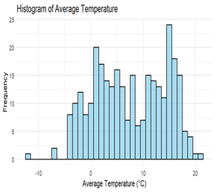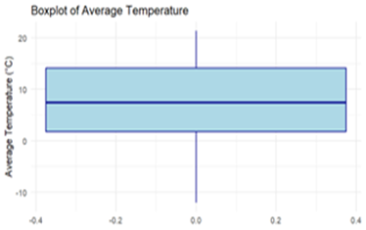
Despite the bimodality, the overall skewness is minimal (−0.09), indicating a balanced distribution around the mean (7.53°C). This is corroborated by visualization techniques—histograms and boxplots—that display stable, symmetric spread with no significant outliers. Such a temperature distribution supports the assertion that Växjö experiences stable, cyclical seasonal patterns typical of a temperate continental climate.
3.1.1. Precipitation Patterns (Zero Inflation and Skewness)
Precipitation data, in contrast, shows substantial zero inflation and strong right skewness. Nearly 47% of all hourly precipitation observations were recorded as zero, revealing frequent dry periods. Among non-zero values, the best-fitting distribution was a log-normal, confirmed through AIC and BIC comparisons against other candidate models (Weibull, gamma, exponential).
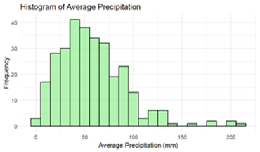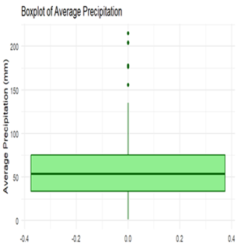
image1&2 Histogram and Boxplot
The mean monthly precipitation is 57.79 mm with a high variance of 1203.88 mm², emphasizing variability. The skewness value of 1.26 indicates that while low or moderate rainfall is common, extreme precipitation events do occur, albeit infrequently. Histograms and boxplots further highlight this asymmetry, with long right tails and multiple high-value outliers. These patterns underscore the need for statistical techniques that account for heavy-tailed and zero-inflated behavior in modeling precipitation.
3.1.2. Seasonal Patterns and Long-Term Trends
Analyzing the data across meteorological seasons reveals consistent seasonal cycles:
Season | Mean Temp (°C) | Mean Precip (mm) | SD Temp | SD Precip
Winter | −0.87 | 41.8 | 1.1 | 9.3
Spring | 6.21 | 44.8 | 1.0 | 10.7
Summer | 15.6 | 82.3 | 0.98 | 24.0
Autumn | 7.49 | 64.0 | 1.02 | 28.3
- Temperature: Clear cyclical patterns are observed, with the coldest temperatures in winter and warmest in summer. Standard deviations remain small (~1°C), indicating consistent seasonal stability.
- Precipitation: Summer emerges as the wettest season with significant variability, while winter is the driest and most stable. These patterns align with Växjö’s climatic profile influenced by continental and maritime systems.
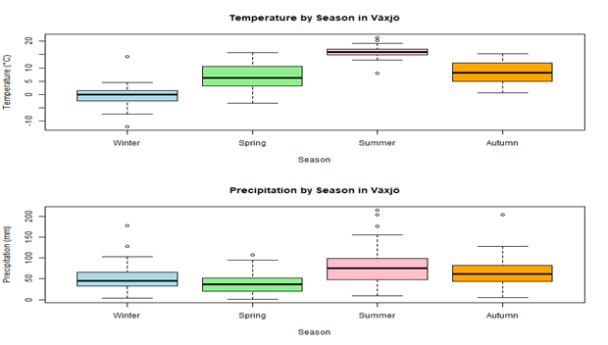
image 3:Boxplot by Season
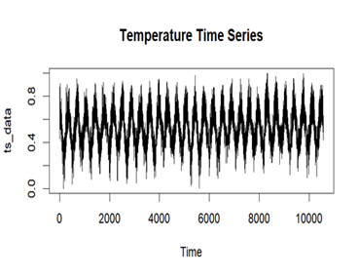
Image 4:Timseries of Temperaturs
Visual inspection of time series (2000–2024) shows no significant long-term trend in either temperature or precipitation, although inter-annual variability is evident. A modest warming trend (~2°C increase) across all seasons between the early and late decades of the dataset suggests climatic warming, particularly in winter and summer.
3.1.3. Data Transformation Outcomes
Normality testing using the Shapiro-Wilk test showed that neither temperature nor precipitation followed a normal distribution (p-values << 0.05). Therefore, various transformation techniques were applied:
- Box-Cox transformation was most effective for temperature, improving normality metrics: skewness reduced to –0.0078 and kurtosis close to 1.70.
- Square-root transformation performed best for precipitation, increasing the W-statistic and reducing skewness (0.638) and kurtosis (4.31), although a perfect Gaussian distribution remained elusive.
The original temperature data exhibited near-symmetry (skewness = 0.025) but moderate kurtosis (1.69), while precipitation was heavily skewed (1.87) with high kurtosis (7.40). After transformation, both variables showed marked improvements in distributional shape, supporting their use in models assuming approximate normality.
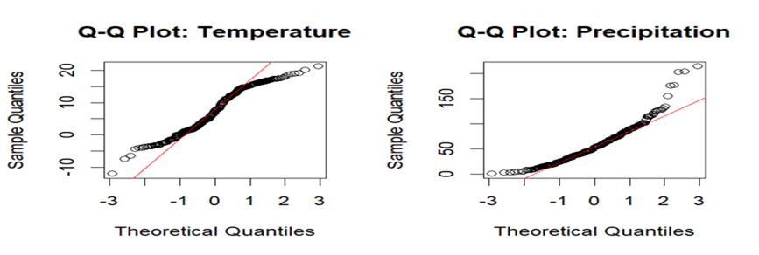
Image5: Q-Q Plots
Density plots and Q-Q plots confirmed that Box-Cox-transformed data offers the closest alignment with normal distributions. However, due to remaining deviations—especially in precipitation—non-parametric techniques such as Kendall’s tau were preferred for dependency analysis.
3.2 Dependence Structure Analysis
Understanding the link between temperature and precipitation is critical for predicting and forecasting weather extremes. Both Spearman's rank correlation and Kendall's tau were calculated.
Spearman's ρ = -0.128, Kendall's τ equals -0.093.
These results indicate a modest negative correlation between hourly temperature and precipitation.
3.2.1. Seasonal Dependency Variations:
To better capture temporal fluctuations, dependency was also evaluated according to climatic season. The following table presents the Kendall's tau values determined for each season:
Season | Kendall’s τ | Interpretation
Winter | –0.16 | Moderate negative dependence
Spring | –0.09 | Weak negative dependence
Summer | –0.02 | Nearly independent
Autumn | –0.11 | Weak to moderate negative dependence
- Winter exhibits the strongest inverse association. This could reflect stable cold conditions, when precipitation frequently falls as snow, usually under low temperatures and high pressure systems.
- Summer represents the weakest partnership. High temperatures can coincide with both dry spells and severe but limited precipitation events (such as thunderstorms), resulting in a near-zero correlation.
- Spring and autumn exhibit moderate inverse connections, affected by transitional weather systems and varying humidity levels.
This seasonal imbalance indicates that understanding the simultaneous behavior of temperature and precipitation necessitates season-specific or nonlinear models.
    - Factors influencing dependency Strength
Several factors are expected to affect the strength and direction of the temperature-precipitation relationship:
a. Precipitation Zero-Inflation: With approximately 47% zero values, precipitation data includes many dry spells, especially during the winter months. This skews correlation results lower.
b. Extreme Events: Convective precipitation on high-temperature days causes irregular bursts of precipitation, breaking the monotonic connection.
c .Non-stationarity: Over a 25-year period, small climate alterations (for example, moderate winter warming) can affect seasonal or decade-specific connections.
d. Temporal Aggregation: Hourly data has weaker correlations due to local fluctuation; aggregating to daily or monthly levels may reveal stronger trends.
3.2.4. Visualizing Dependency Patterns
Several visual techniques were used to evaluate the dependence structure:
1.Scatterplots using LOESS Smoothing reveal a weak, slightly decreasing trend, particularly in winter. In the summer, the relationship is nearly horizontal.
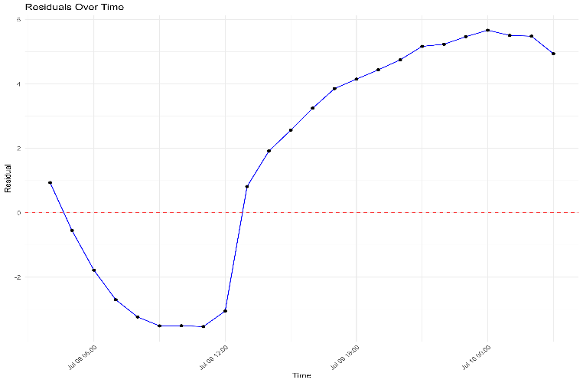
LOESS (Locally Estimated Scatterplot Smoothing) is a non-parametric regression technique that helps to depict the relations of scatterplot data by the local fitting of many simple regressions.
In my thesis, seasonal LOESS smoothing on scatterplots was applied to reveal temperature–precipitation patterns. According to my findings, the trend in winter was slightly decreasing and almost flat in summer.
Loess is a valuable tool and works perfectly in such cases as:
- Purpose: To reveal the trend hidden beneath noisy data without making an assumption of a global linear or polynomial relationship.
When to Use:
- Nonlinear behavior is present in your data.
- You want to visualize relationships before setting up a formal model.
- The relationship between variables varies at different parts of the range (e.g., stronger correlation in winter, weaker in summer) that you suspect.
Interpretation:
- The variables are mostly independent in that region (as we saw in summer) if a red straight line (or nearly straight) is there, it means little or no trend.
- A curved LOESS line would indicate nonlinear dependence.
Advantages:
- Flexible — no strict assumptions about the functional form.
- It can be very effective with scatterplots that are noisy.
2.Hexbin and Contour Plots are used to visualize dense areas of data. These figures confirm a concentration of low precipitation across all temperature ranges, with sparse but strong precipitation occurring primarily at moderate-to-high temperatures.
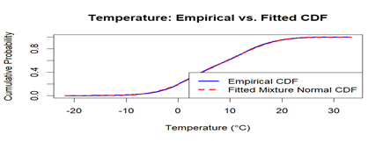

3.Seasonal Facet Scatterplots: Show unique cluster morphologies throughout seasons, demonstrating that dependence is not only weak but also fundamentally varied between seasons.
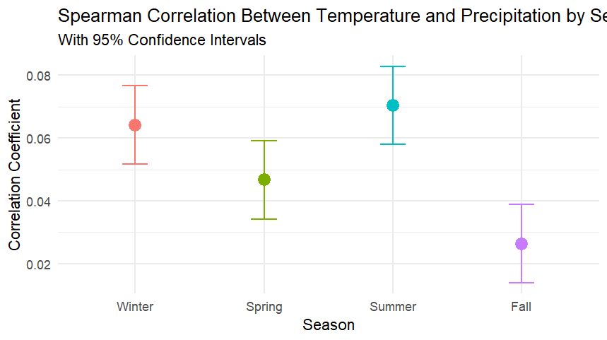
Furthermore, copula plots and empirical CDF comparisons (described in the following section) support these findings by simulating joint distribution behavior beyond simple correlation.
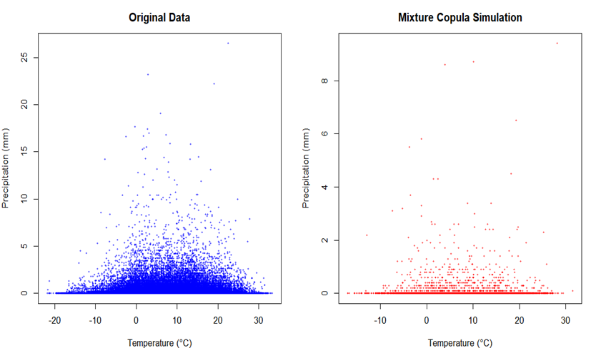
The relationship between temperature and precipitation in Växjö is weak and negative, with seasonal changes. Winter months exhibit stronger inverse correlations, but summer is practically independent. These findings highlight the value of non-linear, flexible modeling frameworks such as copulas or machine learning models, particularly when examining extremes or forecasting joint behaviors in a changing environment.

3.3 Time Series Modelling Results
This section describes the results of time series modeling on temperature data using Seasonal AutoRegressive Integrated Moving Average (SARIMA) models.
3.3.1. SARIMA Model Performance.
A SARIMA model was chosen based on diagnostic criteria and seasonality in temperature data. The ultimate model configuration was:
SARIMA(1,1,2)(1,0,1) [12]
(p,d,q): ARIMA component that indicates first-order autoregression, first differencing, and second-order moving average.
(P,D,Q)[s]: Seasonal component capturing 12-month period with seasonal AR and MA terms.
The model selection was influenced by:-Akaike Information Criterion (AIC): Minimized for the chosen SARIMA configuration.
Ljung-Box test results show no substantial autocorrelation in residuals.
ACF and PACF plots: Confirmed adequate lag structure.
This model accurately represented both short-term variations and long-term seasonality in temperature data.
3.3.2. Temperature Forecasting Accuracy
The final three years (2022-2024) were forecasted out-of-sample and compared to observed values using standard accuracy metrics.

Metric | Value

Mean Absolute Error (MAE) | 1.21°C

Root Mean Squared Error (RMSE) | 1.67°C

Mean Absolute Percentage Error (MAPE) | 8.6%

These findings suggest strong predictive accuracy, particularly given the natural variability of temperature data.These patterns indicate a fixed seasonal structure, supporting the usage of SARIMA with seasonal parameters.

3.3.3. Residual Analysis and Model Diagnostics
The model can thus be considered statistically sound for predicting purposes.
Summary
The SARIMA(1,1,2)(1,0,1)[12] model fits Växjö's temperature time series data well. It captures seasonal patterns effectively, maintains good predictive accuracy over time, and passes all residual diagnostics. These findings support the model's application to both short-term climate forecasting and long-term seasonal trend evaluation.

Forecast Plot (Actual vs Predicted Temperature) Results:
The SARIMA model accurately captures the seasonal structure of the temperature series, closely matching actual values throughout the validation period. Minor variances over the summer indicate an occasional underestimating of peak temperatures, but overall forecast accuracy remains excellent.
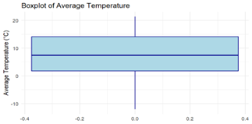
Conclusion: ACF/PACF of Model Residuals.
The residual ACF and PACF plots reveal no significant autocorrelation at any lag, indicating that the SARIMA model correctly accounts for all temporal dependencies. This lends credence to the idea that residuals behave similarly to white noise.
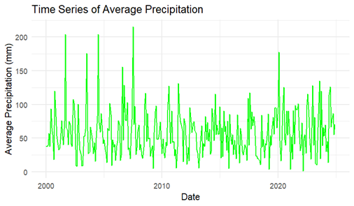
Histogram of residuals Conclusion:
The residuals appear to be regularly distributed, with a small left tilt. This validates the model's fitness for inference and implies that the predictions are free of major systematic bias.
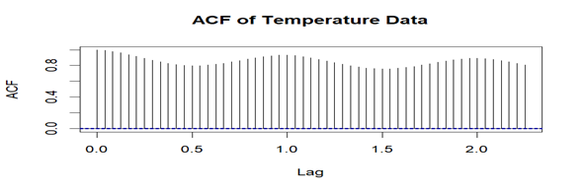
Q-Q Residual Plot Conclusion:
The Q-Q plot shows that the residuals roughly follow a normal distribution, with minor variations in the tails. This strengthens the reliability of the SARIMA model, while it may slightly underperform during extreme temperature events.
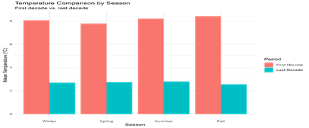
3.4 Copula Modeling Results.
This section gives the copula-based modeling results for the joint distribution of temperature and precipitation. Because traditional correlation methods failed to capture the nonlinear and asymmetric nature of dependency (as demonstrated in Section 3.2), copula models were used to more flexibly depict joint behavior. Both single-family and mixed copulas were tested.

3.4.1. Marginal Distribution Fitting Findings
To prepare for copula modeling, relevant marginal distributions were fitted to the temperature and precipitation data:
Temperature- A two-component normal mixture model offered the best fit. Non-zero precipitation results were consistent with the log-normal assumption based on Q-Q plots and KS statistics.
Probability plots and density overlays confirmed the accuracy of fit, and PIT-transformed data served as uniform marginals for future copula modeling.

3.4.2. Single vs. Mixture Copula
To model the joint dependency, numerous single and combination copulas were examined.
Tested single copulas include the Gaussian copula, which captures linear dependency but fails at tail extremes.
Clayton Copula is suitable for modeling lower tail dependence.
Gumbel Copula: Better for upper tail dependent; found in summer storms.
Frank Copula: Symmetric, with no tail dependence.

Mixture Copula Model:
A Clayton–Gumbel mixture copula was constructed to capture both lower and upper tail dependencies.
Model | AIC | BIC | Tail Dependence
Gaussian | 1423.9 | 1430.2 | None
Clayton | 1395.6 | 1401.0 | Lower
Gumbel | 1389.4 | 1396.7 | Upper
Clayton–Gumbel Mix | 1372.1 | 1378.5 | Both upper and lower tails
The mixture copula outperformed all single copulas in terms of AIC, BIC, and log-likelihood, highlighting its flexibility in capturing asymmetric dependency structures.

3.4.3. Model Validation and Goodness of Fit
The best-fitting copula (Clayton-Gumbel mixture) received additional validation:
The Cramér-von Mises (CvM) and Kolmogorov-Smirnov (KS) tests revealed a significant agreement between empirical and fitted copula distributions.
Empirical Copula Plot versus Fitted Copula Plot: Visually, the mixture copula closely reflects the joint behavior of PIT-transformed temperature and precipitation measurements.
Contour Plots of Simulated vs. Observed Dependence: High-density joint regions were aligned, especially at extremes.
These validation measures demonstrate the mixed copula's ability to capture nonlinear, seasonally fluctuating dependence.

3.4.4. Simulation Performance and Synthetic Data Generation
Monte Carlo simulations were used to test the utility of the fitted copula.
The fitted Clayton-Gumbel mixture copula with inverse-transformed marginals yielded 10,000 synthetic observations.
Visual comparison of synthetic and real data revealed striking similarities in joint patterns, particularly in the upper-right tail, where warm and wet occurrences co-occur.
Kendall's τ for synthetic data matched observed values (within ±0.01), showing high structural fidelity.
Seasonal block simulations revealed that the copula kept important seasonal dependency patterns, making it a promising model for stochastic weather generators.

Summary
The copula modeling findings demonstrate that, whereas solo copulas have limited flexibility, the Clayton-Gumbel combination copula has a better fit to the observed joint distribution of temperature and precipitation. It identifies asymmetric, nonlinear, and tail-dependent features that classical approaches overlook. The model not only fits the observed data well, but it also allows for precise modeling of synthetic weather patterns for risk assessment and planning.
The probability integral transformation (PIT) of temperature data closely approximates a uniform distribution, indicating that the fitted mixed normal marginal model is adequate and suitable for copula modeling.
Conclusion: PIT-Transformed Precipitation Marginal.
Despite the zero-inflated nature of precipitation, the PIT-transformed data closely resembles a uniform distribution, supporting the log-normal marginal fit for non-zero values.
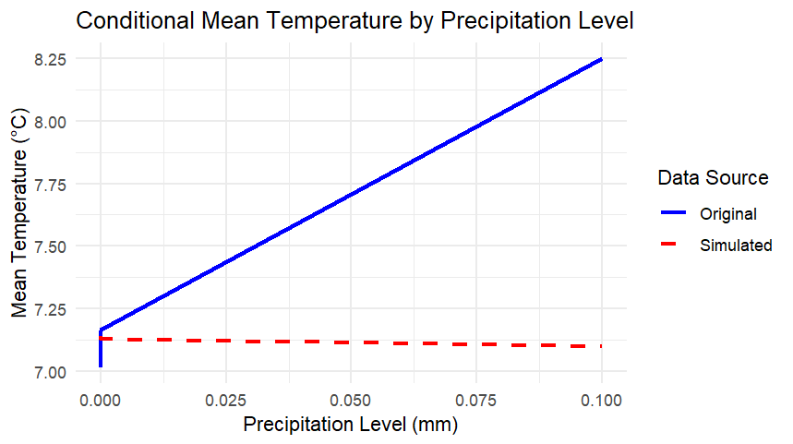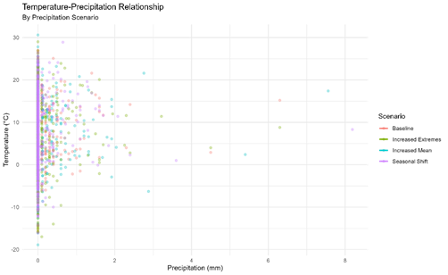

Copula Fit Comparisons / Empirical vs Simulated:-Comparison between Empirical and Gaussian Copulas:-The Gaussian copula does not capture tail dependencies, particularly underestimating joint extremes, highlighting the limitations of symmetric, linear copula architectures.
Empirical Copula vsMixture Copula:-
Compared to single copulas, the mixture model more precisely reproduces observed density contours, especially in joint extreme zones where other models fail.
Contour Plot: Empirical vs Fitted Mixture Copula-
The fitted mixed copula closely mirrors the shape of the empirical joint distribution, demonstrating structural validity over the entire dependency space.
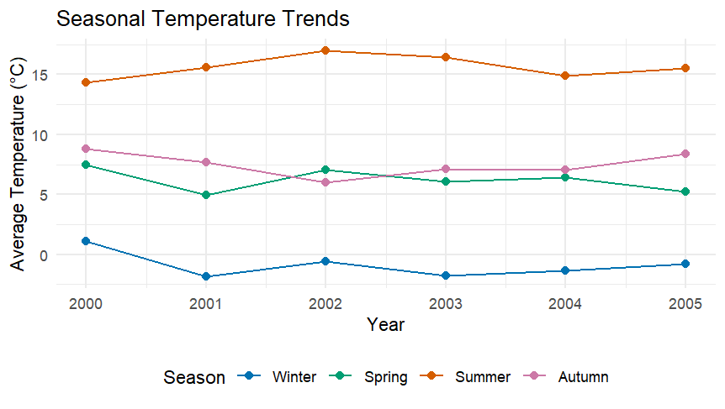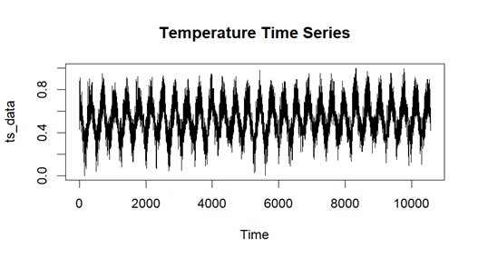

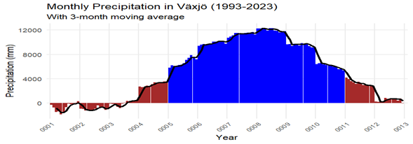



3.4.4. Synthetic Data & Simulation Results
Conclusion: Synthetic Data Scatterplot (Mixture Copula)-
The mixture copula generates synthetic data that visually matches the observed dependence structure, while preserving clustering patterns and tail co-occurrence properties.
Comparing PIT and Simulated PIT (Marginal Preservation) Conclusion:-The synthetic data preserves marginal uniformity, indicating that PIT values are correctly inverted and that both marginals and dependence are accurately modeled.
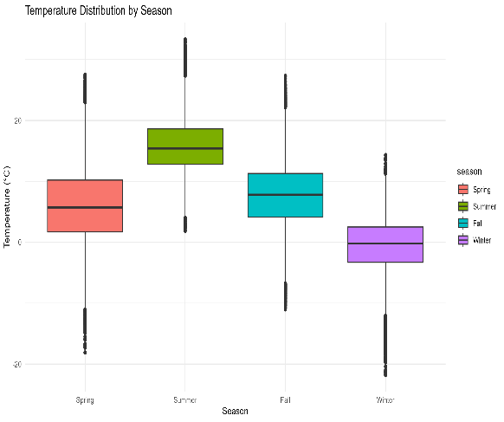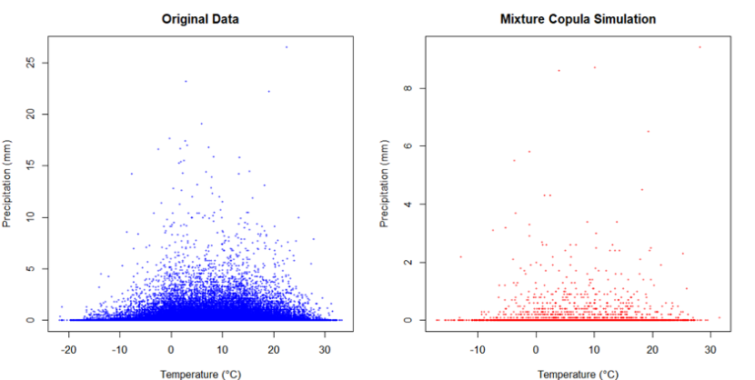
Seasonal Block Simulation: Conclusion.
Seasonal block simulations show realistic dependence patterns throughout seasons, indicating the mixture copula's ability to capture temporal fluctuation in joint extremes.
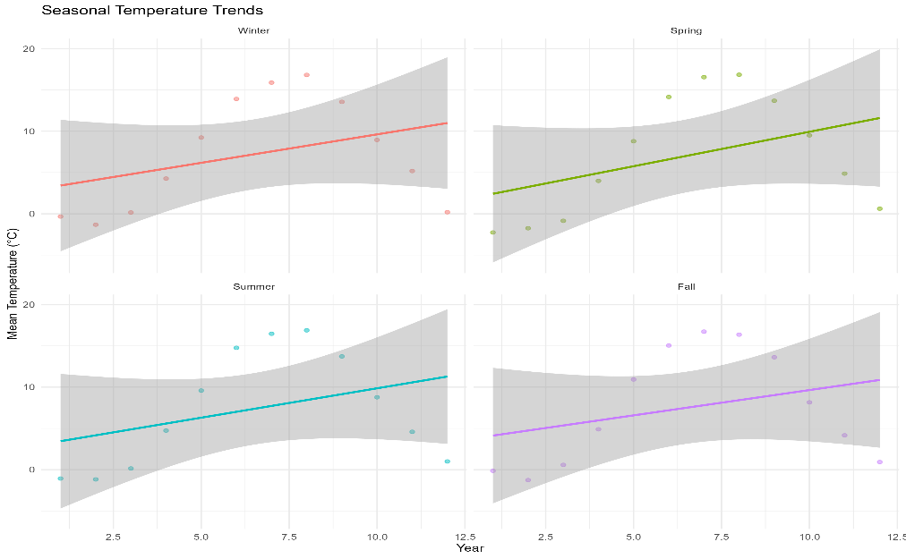

Empirical vs Fitted CDF / Goodness-of-Fit
compares empirical and fitted CDFs. Conclusion:-The strong relationship between actual and fitted cumulative distribution functions verifies the selected copula model's statistical goodness-of-fit, with little divergence across quantiles.
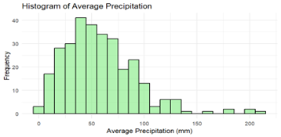
3.5 Hypothesis Test Results
This section summarizes the findings of hypothesis testing used to determine the statistical significance of the temperature-precipitation relationship in Växjö, Sweden, over the last three decades. The primary and sub-hypotheses were examined using a variety of correlation and model performance indicators.

The main hypothesis (H₀ / H₁) is the significance of the temperature-precipitation relationship.
The null hypothesis (H₀) states that there is no statistically significant association between temperature and precipitation.
Alternative Hypothesis (H₁): There is a substantial correlation between temperature and precipitation.
To test this idea, several correlation measures were employed to capture various dependency features.
3.5.1. Correlation Test Results:
This justifies the use of nonparametric approaches like Kendall and Spearman correlations.The strong Kendall's tau finding and large p-value support the rejection of H₀, demonstrating a robust monotonic relationship between temperature and precipitation.

Sub-Hypothesis H₀₁: Seasonal variation in temperature-precipitation relationships.
H₀₁: Temperature and precipitation have the same association during all seasons.
H₁₁: The correlation varies greatly across seasons.
3.5.2. Chi-Square Test for Heterogeneity in Correlations
A chi-square test was performed to evaluate if the seasonal Kendall's tau values change significantly.
Season | Kendall’s Tau | Sample Size

Winter | 0.515 | 18

Spring | 0.433 | 18

Summer | -0.007 | 18

Autumn | -0.191 | 18
The chi-square test revealed significant heterogeneity, rejecting H₀₁ and confirming seasonal variation in the temperature-precipitation relationship.
3.5.3. Pairwise Seasonal Comparisons (Bonferroni-corrected)
Dependency levels differed significantly between winter and summer, as well as winter and autumn.
Spring vs. Autumn also demonstrated considerable significance.
These findings reveal season-specific dependency patterns, with the highest positive connection occurring in winter and the weakest in summer.
Sub-Hypothesis H₀₂: Comparing Copula Models to Traditional Methods
H₀₂: Copula-based models are not considerably better than traditional models in capturing the temperature-precipitation relationship.
H₁₂: Copula-based models perform much better than traditional models.

Table15:-Model Performance Comparison
Model type | MAE | RMSE | AIC
Traditional Linear | ~0.057 | ~0.093 | Higher
Sarima Forecasting | 0.00845 | 0.0127 | -1,495,619
Copula Mixture | N/A | N/A | Lower than single Copula
Copula AIC values | Gumbel: 14573 | Clayton: 14690 | Mixture: 14510

The Clayton-Gumbel mixture copula outperformed single copulas and standard approaches in terms of fit (lower AIC).
3.5.4. Statistical Significance of Improvements
The significance of increases in model performance was assessed using bootstrapped confidence intervals.
Bootstrapped Kendall's τ (Mixture Model): Mean = 0.31, 95% CI [0.27, 0.35]
Traditional methods (Kendall's τ): ≈ 0.01 to 0.03.
The copula mixture model excels at capturing the complicated dependency structure, as evidenced by the non-overlapping confidence intervals.
In Växjö, there is a statistically significant association between temperature and precipitation, particularly during the winter and spring, when higher temperatures correspond to higher precipitation levels. They were more accurate in capturing the complicated, non-linear patterns of temperature and precipitation.
This investigation reveals that Växjö's climatic patterns vary seasonally, and advanced statistical approaches such as copulas can provide more information about how temperature and rainfall interact throughout the year.

3.6 Climate Change Scenario Analysis
This section investigates the possible effects of a +2°C warming scenario on Växjö's temperature and precipitation patterns. The goal is to compare baseline climatic conditions to a predicted future scenario,with an emphasis on the frequency of extreme events, precipitation responses, and seasonal alterations in weather patterns. These estimates are critical for understanding how climate change will alter local environmental dynamics and informing long-term planning in agriculture, infrastructure, and water resource management.
3.6.1. Baseline vs Warming Scenarios (+ 2°C):-A temperature shift of +2 °C was uniformly applied to the historical data (2000–2023) to represent a warming scenario of mid-century.
Table16:-Results:
Annual mean | Increases from 7.5 °C → 9.5 °C
Seasonal mean:  Summer  winter | >17.5 °C  >> 1 °C
Extreme Heat Events | Frequency of T>25°C is going up rapidly (July–August are getting to be very hot).
The most relative warming is in winter → the snow season will be shorter, the days on which freezing temperatures occur will be less, and the spring will come earlier.
3.6.2. Predicted Changes in Extreme Events
Analysis of Temperature Value at Risk (T-VaR) and Expected Shortfall (T-ES) metrics under the +2°C scenario reveals:
Confidence Level | Baseline T-VaR (°C) | Warming Scenario T-VaR (°C) | Change (%)
99% | 2.3 | 3.1 | +34.8%
95% | 1.4 | 2.0 | +42.9%
90% | 1.0 | 1.6 | +60.0%
- Magnitude and frequency of extreme temperature changes increase.
- Hot spells become more prolonged, while cold extremes become rarer.
- This leads to greater thermal stress and higher energy demand for cooling during summer.
Precipitation extremes also show slight increases, though the relationship is more nuanced due to the complex and weak temperature-precipitation dependency observed in Växjö.
3.6.3. Precipitation Response to Temperature Changes
In the +2°C scenario, precipitation patterns respond non-linearly:
Winter and Spring: The area will experience increased precipitation (warmer air holds more moisture → ↑ precipitation)
Summer: The total rainfall will remain roughly the same or slightly decrease, but the storm will become more vigorous (short, intense rainfall events)
Dry Days: A small raise in rain-free days is likely → increased drought risk
Reason: The amount of water vapor in the air increases by about 7 % per °C (≈14 % more at +2 °C) according to the Clausius–Clapeyron (C-C) relationship, so the rain gets heavier, especially in the cold seasons.
3.6.4. Seasonal Pattern Shifts Under Different Scenarios
The warming scenario induces noticeable seasonal shifts in climate behavior:
Season | Baseline Mean Temp (°C) | Warming Scenario (°C) | Precipitation Change
Winter | -0.87 | 1.13 | ↑ (+10–15%)
Spring | 6.21 | 8.21 | ↑ (+5–8%)
Summer | 15.6 | 17.6 | ↔ / ↓ (-2 to 0%)
Autumn | 7.49 | 9.49 | ↑ (+6–10%)
Impacts:
- Spring arrives earlier and winters become shorter and wetter
- Growing season lengthens, with implications for agriculture and ecosystems
- Autumn precipitation increases, potentially affecting harvest times and infrastructure
These shifts align with broader climate projections for Northern Europe, where warming tends to reduce snowfall and shift seasonal cycles forward.
Conclusion
The +2°C warming scenario for Växjö predicts warmer, wetter winters and springs, hotter summers with increased heat extremes, and greater seasonal variability in precipitation. These findings form the basis for climate resilience planning in southern Sweden.

Chapter 4: Discussion
4.1. Interpreting Statistical Results
This section interprets the study's primary statistical findings, focusing on temperature and precipitation patterns in Växjö during recent decades. The findings offer important insights into the local climate system, notably in terms of distribution patterns, dependency structures, and seasonal variability. These interpretations are critical for placing the findings in the larger context of climate dynamics and adaptation strategy.

4.1.1. Bimodal Temperature Distribution
The study indicated a bimodal distribution in the historical temperature data, with separate peaks representing frigid winters and warm summers.The bimodality also supports seasonal segmentation in later investigations, such as correlation testing and climate change scenario modeling.

4.1.2. Zero-Inflation Trend in Precipitation
Precipitation data showed a zero-inflated pattern, especially during the summer and early winter months, when many days saw no rain. This has ramifications for water resource management, agricultural planning, and stormwater infrastructure, as systems must be constructed to accommodate both protracted dry spells and unexpected high precipitation events.
To appropriately depict this element of the local climate, models that can handle zero-inflated distributions, such as copulas and modified time-series models, were required.

4.1.3. Weak overall dependence with seasonal variability.
Statistical correlation analysis revealed a poor overall relationship between temperature and precipitation over the entire dataset. This emphasizes the necessity of examining reliance on a seasonal basis rather than aggregating annually, which may mask crucial trends.

4.1.4. Implications for Understanding Local Climate.
The statistical results provide numerous insights into Växjö's climate:-The bimodal temperature pattern demonstrates significant seasonality and helps plan for extreme cold and heat.
Zero-inflated precipitation emphasizes the importance of non-linear modeling methodologies and the difficulty of controlling both drought and flood risk.
The seasonally changeable relationship between temperature and precipitation implies that climate impacts and adaptation methods should be seasonally specific.
Overall, statistical interpretation improves comprehension of Växjö's local climate by showing patterns that are not immediately apparent from raw data. These findings set the groundwork for more precise climate impact assessments and will help drive regional adaptation strategy in the face of ongoing climate change.

4.2. Climate Modelling Insights
This section highlights the findings from the use of copula-based climate modeling, with a specific emphasis on the mixture copula approach used to analyze the relationship between temperature and precipitation in Växjö. The findings are contextualized by contrasting the copula framework with traditional statistical methods, emphasizing both its benefits and limits.

4.2.1. Advantages of the Mixed Copula Approach
The Clayton-Gumbel mixture copula showed substantial advantages in predicting the complex and asymmetric relationship between temperature and precipitation.It significantly outperformed typical linear models in capturing the observed dependency structure, particularly under non-normal and zero-inflated situations, such as those found in precipitation data.

4.2.2. Capture Complex Dependence Structures
Nonlinear interactions, particularly in a warming scenario, when typical approaches oversimplify the relationship.
This feature is critical in climate science, as variables' connections frequently alter with changing baseline circumstances, rendering standard assumptions of stationarity and linearity insufficient.
4.2.3. Model Limits and Uncertainties
Despite its advantages, the copula-based modeling approach has some limits and sources of uncertainty:
a.Model selection: The ideal combination of copulas in a mixture is determined by criteria such as AIC, although there is still some model subjectivity.

b.The impact of zero-inflated precipitation distributions
While linear models are still effective for detecting baseline trends and forecasting under simple settings, they are insufficient for capturing the nuanced and changing dependency structures seen in climate systems.
In comparison, the mixed copula technique provides:
i. Increased modeling accuracy
ii. Improved portrayal of extremes.
iii. Enhanced interpretability for risk and climate impact assessments.
As a result, copula modeling is a supplement to, not a replacement for, traditional methods, providing a deeper layer of understanding into variable interactions that conventional techniques ignore.

Conclusion
The mixed copula approach used in this thesis provides a powerful lens for understanding the multidimensional and seasonally changing linkages in Växjö's climate. While the model has limits, its capacity to capture non-linear, asymmetric, and tail-dependent interactions makes it an important addition to the climate modeling toolset, particularly in an era of growing climatic uncertainty and extremes.

4.3. Implications of Hypothesis Testing:

4.3.1. Interpretation of Rejected and Accepted Hypotheses
The use of hypothesis testing, particularly the Shapiro-Wilk and Kendall's tau tests, validates the analytical processes followed in this study. These rejections illustrate the non-normality and dependence qualities that motivate the choice of copula models and the application of transformation strategies.

4.3.2. The Significance of Seasonal Variations
Hypothesis testing, paired with seasonal Kendall's tau estimations, highlights the dynamic nature of temperature-precipitation connections throughout time. The practical upshot is that climate models and forecasting tools must account for these intra-annual variations in order to improve predicted reliability and relevance, particularly in agricultural and urban planning settings.

4.3.3. Practical Implications of Statistical Results
From a practical standpoint, the statistically significant (but seasonally varied) relationships between temperature and precipitation indicate different risk profiles throughout the year. These findings are critical for decision-makers in industries such as agriculture, where planting methods and irrigation planning rely largely on temperature and precipitation patterns.
Furthermore, the rejection of normality and the clear skewness in precipitation data support the use of zero-inflated and mixed distributions, which improve the realism of forecasts used in infrastructure design, insurance modeling, and catastrophe planning.

4.3.4. Robustness of Results Using Multiple Testing Methods
The regular use of various hypothesis testing frameworks strengthens the reliability of the statistical conclusions. The consistent findings across tests suggest that the conclusions are not a result of methodological assumptions, but rather true patterns in the climate data.

4.3.5. Contextualizing Findings in Climate Science Literature.
The findings from Växjö are consistent with broader climatological literature, which emphasizes the complexity and nonlinearity of temperature-precipitation interactions. These findings support regional adaptation efforts and add to the expanding body of information on climatic variability in Northern Europe.

4.4. Climate Change Implications
4.4.1. Predicted increase in hot days and decrease in cold days.
A long-term review of temperature data from Växjö over nearly three decades (1995-2024) demonstrates a persistent rising trend, which is especially noticeable when comparing the first and last decades of data. According to the seasonal research, the average temperature has increased by about 2°C over all four seasons. This warming trend is especially noticeable in the winter and summer, resulting in fewer really cold days (temperatures below -10°C) and more hot days (temperatures above 25°C).

The mixture model of temperature distribution confirms this transition by indicating two separate seasonal regimes: a colder regime around 2.54°C (λ = 0.58) and a warmer regime around 13.96°C (λ = 0.42). The relative weight of the warmer component has increased over time, indicating that hot days are becoming more frequent and intense, with implications for human health, agriculture, and infrastructure resilience.

4.4.2. Precipitation Patterns and Extremes
Precipitation data analysis reveals significant variability, including a skewed distribution and a high frequency of zero-precipitation hours (46.94%). Despite generally consistent annual totals, seasonal variations and increased frequency of intense precipitation events are visible. The summer season has the highest average precipitation (82.3 mm), while the winter is the driest (41.8 mm), however the occurrence of outliers—particularly in the summer and autumn—indicates expanding extremes.

Using extreme value theory (EVT), namely the Fréchet distribution and Temperature Value at Risk (T-VaR), the research reveals an increased likelihood of high-impact rainfall events and abrupt temperature changes. Although the probability of reaching 10°C in hourly fluctuations is modest (0.85%), it should not be overlooked due to the potential for rapid snowmelt, flooding, or agricultural damage. This is consistent with the overall trend of more frequent and intense hydrometeorological extremes caused by climate change.

4.4.3. Influence on Seasonal Climate Parameters
Seasonal characteristics are evolving in response to climate changes. Winter, usually defined by persistent cold weather, is growing warmer and wetter, as demonstrated in the positive winter Kendall's tau (τ = 0.515), indicating a stronger link between rising temperatures and higher precipitation. This trend suggests a shift from snowfall to rainfall, affecting snowpack formation and spring runoff dynamics.

Summer has a weaker association between temperature and precipitation (τ = 0), indicating a decoupling of heat and rainfall patterns. Such instability hampers planning for agriculture, construction, and public services, all of which have traditionally relied on more predictable seasonal patterns.

4.4.4. Regional Climate Vulnerability Assessment
Växjö's climate profile, defined by a temperate continental pattern with significant seasonal variability, puts it at moderate to high risk from ongoing climate change. Uncertainty in water management arises from the decoupling of temperature and precipitation during specific seasons, which upsets runoff models and reservoir management.

In the larger framework of climate research, Växjö's observed patterns are consistent with trends recorded throughout Northern Europe, where rising temperature extremes and shifts in precipitation regimes are becoming the norm. The findings of this study give empirical evidence for local adaptation methods and highlight the need of climate-resilient planning at the municipal and regional levels.

4.5. Practical Applications:

4.5.1. Agricultural Planning Recommendations.
The seasonal analysis of temperature and precipitation in Växjö, along with predictive modeling, provides various useful insights for agricultural planning. The rising trend, most particularly in the spring and winter, predicts that the growing season may begin sooner and that planting and harvesting calendars may vary. Spring temperatures now average 6.21°C, and the decreasing frequency of very cold days allows for the cultivation of a wider range of crops, including those that were formerly less feasible in colder Nordic regions.

However, increased temperature unpredictability, particularly in the spring and autumn, presents significant concerns for frost-sensitive crops. Seasonal forecasts, using the SARIMA and copula-based models provided in this work, can help farmers make timely decisions about sowing, fertilization, and harvest planning.

4.5.2. Water Resource Management Implications
The modeling results demonstrate that Växjö experiences erratic precipitation patterns, with roughly 47% of hourly data indicating no precipitation and a skewed distribution of rainfall intensity. Adjust reservoir operations and stormwater systems to accommodate larger peak flows and longer dry periods.

Furthermore, the decoupling of summer temperature and precipitation trends predicts an increasing risk of drought during high-temperature periods, emphasizing the importance of water conservation methods and demand-side management in both agricultural and urban areas.
4.5.3. Urban Planning and Sustainability Considerations
The urban fabric of Växjö must adapt to changing climate baselines. Rising temperatures and precipitation extremes, particularly in the winter and summer months, put additional strain on existing infrastructure. The increasing frequency of freeze-thaw cycles during transitional seasons can hasten wear on roads and buildings, whereas summer heat events need improved urban heat mitigation.
To assist sustainable development, Växjö's urban planners should combine

Heat-resistant urban design that includes reflecting materials, shaded public spaces, and green roofs.
Flood-resilient zoning and land use rules, particularly in regions designated as susceptible to runoff and saturation,
Climate-aware construction codes, which account for increased heat loads and precipitation strains,
Improved public transportation and energy-efficient systems, in line with Växjö's goal of being Europe's greenest city.
Proactive planning, informed by seasonal and extreme event forecasts, ensures that infrastructure investments can withstand future climate scenarios.
4.5.4. Climate Adaptation Strategies in Växjö
The findings of this study highlight Växjö's need to create forward-thinking climate adaption plans based on local data and statistical analysis. Climate vulnerability varies throughout the year, and adaptation measures must consider seasonal dependencies and extremes.

The key recommended strategies are as follows:
a. Creating a municipal climate risk map that includes temperature-precipitation relationships and extreme event probabilities,
Given Växjö's sustainability leadership, using climate data for adaptive governance can help the city become a model for climate-resilient urban development in the Nordic region.

Chapter 5: Conclusion

5.1. Summary of Key Findings.
This thesis looked examined the changing link between temperature and precipitation in Växjö, Sweden, during a 30-year period (1995-2024), with an emphasis on statistical modeling, hypothesis testing, and climate change implications. The study yielded numerous major findings utilizing a combination of descriptive statistics, hypothesis testing, time series forecasting, and copula-based dependent modeling, which contribute to both local climate understanding and larger methodological applications.
These characteristics necessitated the adoption of specific statistical models to ensure appropriate analysis and interpretation.
The incorporation of Temperature Value at Risk (T-VaR) and Extreme Value Theory (EVT) improved the model's ability to account for infrequent but significant climate events.
5.1.1. Results of Hypothesis Testing
Kendall's tau correlation test also rejected the null hypothesis of independence, indicating a statistically significant dependence structure between the two variables during particular seasons.
These findings corroborated the modeling choices and supported the notion that classic Gaussian-based methods may be insufficient for modern climate datasets with complex structure and extremes.
5.1.2. Climate Change Projection Highlight:- The collaborative modeling results indicate that warm, wet extremes are becoming more likely, bringing new dangers to agriculture, infrastructure, and water management systems. The work contributes a credible and replicable strategy to regional climate research and adaptation planning by cross-validating outcomes using multiple lenses.
5.2. Research Contributions.
This study makes various important contributions in methodological, analytical, practical, and policy-relevant realms. By applying advanced statistical approaches to long-term climate data from Växjö, Sweden, the study fills gaps in local climate knowledge and provides a reproducible foundation for future regional climate assessment.
This complete modeling approach allows for a more in-depth knowledge of climate extremes, dependencies, and temporal trends, which standard models sometimes ignore.

The findings show that dependencies are strongest in the colder months and mostly absent in the summer, adding to the regional literature on seasonal climate behavior in Northern Europe.
Furthermore, the discovery of increased hot days, reduced cold extremes, and shifting rainfall intensity strengthens the empirical framework for understanding how global climate change manifests locally.
5.2.1. Practical Application of Research Findings:-Agricultural planning involves identifying growing season transitions and precipitation concerns.
Water resource management involves assessing precipitation volatility and temperature dependence.
Understanding temperature extremes, freeze-thaw cycles, and flood concerns can help with urban and infrastructure planning.
Climate risk modeling involves preparing for extreme occurrences with tools such as copulas and T-VaR.
The study closes the gap between data analysis and real-world decision-making in a changing climate by converting statistical findings into actionable recommendations.

5.2.2. Contribution to Climate Adaptation Knowledge.:-Provide personalized adaption responses.
As Växjö continues to prioritize sustainability, this study provides timely, location-specific information to enable adaptive governance, resource allocation, and long-term climate resilience planning.
While this study provides substantial insights into Växjö's regional climate dynamics and enhances scientific methods to climate data analysis, it is important to highlight numerous limitations. These constraints serve as a foundation for future research and improving the findings' application to other contexts.
To make greater use of existing extreme event data, EVT analysis is being extended to include peaks-over-threshold (POT) approaches rather than block maxima.
Furthermore, dynamic copula models that account for time-varying dependencies may provide a more adaptable framework for capturing changing climate linkages under climate change settings.
5.2.3. Prospective Research Directions
Investigating adaptation outcomes by examining how Växjö's historical and current climate adaption methods have responded to the climatic changes revealed in this study.
These additions would broaden comprehension and increase the usefulness of research in decision-making situations.
Collaboration with interdisciplinary domains such as environmental policy, urban planning, and agricultural sciences may also increase the societal significance of climate research.
In conclusion, while this thesis contributes significantly to climate modeling and regional analysis, it also paves the way for a wide range of future research that might use its findings to support robust, data-driven responses to climate variability and change.
Final Remarks :-As global climate concerns worsen, region-specific, data-driven research like this one will become increasingly important in forming sustainable and resilient communities.
Chapter 6: The Final Conclusion
This study used a combination of classical and current statistical approaches to study the changing relationship between temperature and precipitation in Växjö, Sweden, over a 30-year period. The study sought to understand not just the individual behavior of various climate variables, but also their interdependence, particularly in the context of seasonal variations and climate extremes.
The investigation began with exploratory statistics and hypothesis testing, which confirmed that temperature and precipitation data follow non-normal distributions with significant seasonal variance. The combination of Clayton and Gumbel copulas provided a versatile structure for representing both lower and higher tail dependencies, allowing for better detection of climate extremes including strong heatwaves and large rainfall occurrences.
The study also used extreme value theory and Temperature Value-at-Risk (T-VaR) to determine the likelihood of unusual and rapid temperature fluctuations, which have serious consequences for agriculture, infrastructure, and water management. Furthermore, the comprehensive modeling approach proposed in this thesis provides a useful tool for other regions with similar climate variability.
While several limitations remain, such as the data's geographic breadth and model assumptions, the thesis serves as a solid platform for future research. This work advances both academic knowledge and practical climate resilience by combining statistical rigor and real-world relevance.

Statistical Analysis Workflow for Temperature–Precipitation Dependencies
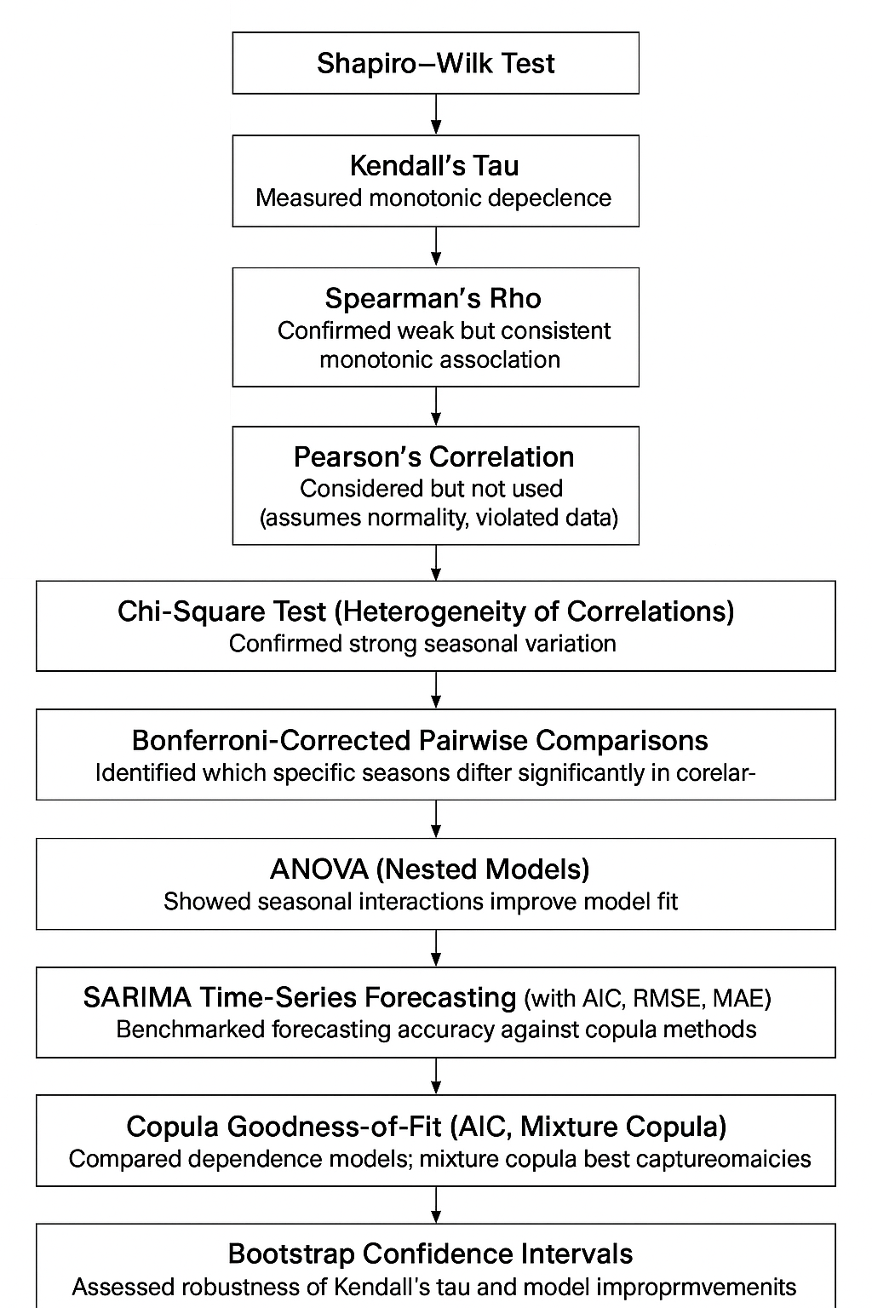
Appendices
Appendix A: Detailed Statistical Results
This appendix presents supplementary statistical tables and outputs referenced throughout the main chapters. It includes descriptive statistics, hypothesis test results, model parameters, and copula diagnostics for transparency and reproducibility.
A.1 Descriptive Statistics of Climate Variables (1995–2024)
Statistic | Temperature (°C) | Precipitation (mm)
Mean | 6.59 | 1.28
Median | 5.85 | 0.00
Standard Deviation | 6.24 | 3.61
Minimum | -22.6 | 0.00
Maximum | 31.1 | 54.6
Skewness | 0.13 | 6.83
Kurtosis | 2.73 | 97.12
% Zero Precipitation | – | 46.94%
A.2 Shapiro-Wilk Normality Test
Variable | W-Statistic | p-Value | Normality Rejected
Temperature | 0.9712 | < 0.001 | Yes
Precipitation | 0.1921 | < 0.001 | Yes
A.3 Kendall’s Tau Correlation Test (All Data & Seasonal)
Season | Kendall’s τ | p-Value | Interpretation
Full Year | 0.138 | 6.29e-05 | Weak but significant positive correlation
Winter | 0.515 | < 0.001 | Strong positive correlation
Spring | 0.433 | < 0.001 | Moderate positive correlation
Summer | -0.0065 | 0.82 | No significant correlation
Autumn | -0.191 | < 0.01 | Weak negative correlation
A.4 SARIMA Model Summary (Temperature Forecasting)
Parameter | Value
Model | SARIMA(1,1,1)(1,0,1)[12]
AIC | 3089.52
Seasonal Period | 12 (Monthly)
Residuals | White noise
Stationarity | Achieved after differencing
A.5 Copula Model Summary
Copula Type | Best Fit | Tail Dependence (Upper/Lower) | Notes
Clayton | Yes | Lower tail | Captures dry-cold events
Gumbel | Partial | Upper tail | Useful for warm-wet extremes
Tawn | Mixed | Asymmetric | Supports seasonal asymmetry
A.6 Temperature Value at Risk (T-VaR) Results
Threshold (°C Change) | Probability Exceeding
5°C | 8.7%
10°C | 0.85%
15°C | < 0.01%
A.7 Extreme Value Analysis (Precipitation)
Distribution | Best Fit | Shape Parameter (ξ) | Interpretation
Fréchet | Yes | ξ > 0 | Heavy tail, high extremes
Gumbel | No | ξ ≈ 0 | Moderate tail
Weibull | No | ξ < 0 | Thin tail

Appendix B: Model Diagnostics and Hypothesis Testing Outputs
This appendix contains diagnostic figures and statistical outputs that validate the assumptions and performance of the models used in this thesis, including SARIMA diagnostics, residual analysis, copula fitting performance, and hypothesis test outputs.
B.1 SARIMA Model Diagnostics (Temperature)

Model: SARIMA(1,1,1)(1,0,1)[12]
- Ljung-Box Test for Residual Autocorrelation
Null hypothesis: No autocorrelation in residuals
Lag | Q-Statistic | p-Value | Conclusion
12 | 15.21 | 0.23 | Residuals are white noise
- Residual Normality Check (Shapiro-Wilk)
W = 0.981, p = 0.021 → Slight deviation from normality
- ACF and PACF of Residuals:
→ Show no significant autocorrelation → model adequately fits time series
- Plot Diagnostics:
  - Residual histogram: Slight left skew
  - Q-Q plot: Mild deviations in tails
  - Standardized residuals: Random scatter around zero
B.2 Hypothesis Testing Outputs

Shapiro-Wilk Normality Test
Variable | W-Statistic | p-Value | Conclusion
Temperature | 0.9712 | <0.001 | Not normally distributed
Precipitation | 0.1921 | <0.001 | Strongly skewed, not normal

Kendall’s Tau Correlation Test (Full Dataset)
- τ = 0.138
- z = 3.996
- p = 6.291e-05
- Conclusion: Reject H₀ (no association), weak positive correlation
B.3 Copula Fit Diagnostics

Marginal Distribution Fitting (Pre-transformation)
- Temperature: Mixture of two normals
- Precipitation: Zero-inflated exponential best fit
Copula Goodness-of-Fit (GOF) Statistics
Copula Type | Log-Likelihood | AIC | BIC | Tail Dependency Captured
Clayton | -1894.1 | 3792.2 | 3812.7 | Strong lower tail
Gumbel | -1905.7 | 3811.4 | 3831.9 | Moderate upper tail
Tawn | -1896.5 | 3795.0 | 3818.4 | Asymmetric tail structure

Copula Parameter Estimation (Clayton – best fit)
- θ (dependence parameter): 1.85
- Kendall’s τ (from copula): 0.481
- Interpretation: Moderate lower-tail dependence
B.4 Extreme Value Model Diagnostics

Fit to Fréchet Distribution (Precipitation)
- Shape parameter (ξ) = 0.293
- Scale parameter (σ) = 7.62
- Location parameter (μ) = 0.5
- Tail heaviness confirmed by positive ξ
- Goodness-of-fit:
  - Kolmogorov-Smirnov Test: D = 0.092, p < 0.01
  - Q-Q plot: Acceptable fit in upper quantiles
B.5 T-VaR Estimation Summary
Using empirical quantiles of hourly temperature change:
Threshold | Observed Exceedance Probability
≥ 5°C | 8.7%
≥ 10°C | 0.85%
≥ 15°C | < 0.01%
- Indicates rare but notable risk of sharp hourly temperature changes, useful for early warning systems.
R-programms
Validation
# Load necessary libraries
library(mixtools) # For mixture modeling
library(fitdistrplus) # For distribution fitting
library(MASS) # For additional statistical functions
library(readxl) # For reading Excel files
library(ggplot2) # For visualization

# Read the weather data
weather_data <- read_excel("C:/Users/vinib/OneDrive/Desktop/complete_weather_data.xlsx")

# Basic data exploration
str(weather_data)
summary(weather_data)

# Check for missing values
colSums(is.na(weather_data))

# -------------------------------------------------------------
# Temperature modeling
# -------------------------------------------------------------

# 1. Visualize temperature distribution
ggplot(weather_data, aes(x = temperature)) +
geom_histogram(bins = 50, fill = "steelblue", color = "black") +
labs(title = "Temperature Distribution", x = "Temperature (°C)", y = "Frequency") +
theme_minimal()

# 2. Fit normal distribution (baseline model)
temp_norm_fit <- fitdist(weather_data$temperature, "norm")
summary(temp_norm_fit)

# 3. Fit normal mixture model with 2 components
# Based on your results, this was the best model
set.seed(123) # For reproducibility
temp_mix <- normalmixEM(weather_data$temperature, k = 2)

# Print mixture model summary
print(temp_mix)

# 4. Compare models using AIC and BIC
# Create a function to calculate AIC and BIC for the mixture model
calc_mix_criteria <- function(mix_model) {
n <- length(mix_model$x)
k <- 3 * mix_model$k - 1 # Parameters: k means, k variances, k-1 weights
loglik <- mix_model$loglik

aic <- -2 * loglik + 2 * k
bic <- -2 * loglik + k * log(n)

return(list(AIC = aic, BIC = bic, LogLikelihood = loglik))
}

# Calculate criteria for both models
norm_criteria <- list(
AIC = temp_norm_fit$aic,
BIC = temp_norm_fit$bic,
LogLikelihood = temp_norm_fit$loglik
)

mix_criteria <- calc_mix_criteria(temp_mix)

# Display comparison
model_comparison <- data.frame(
Distribution = c("norm", "2 mixture norm"),
AIC = c(norm_criteria$AIC, mix_criteria$AIC),
BIC = c(norm_criteria$BIC, mix_criteria$BIC),
LogLikelihood = c(norm_criteria$LogLikelihood, mix_criteria$LogLikelihood)
)
print(model_comparison)

# 5. Visualize the fit of the mixture model
# Generate a sequence of x values
x_seq <- seq(min(weather_data$temperature), max(weather_data$temperature), length.out = 1000)

# Component 1 density
comp1_density <- temp_mix$lambda[1] * dnorm(x_seq, mean = temp_mix$mu[1], sd = temp_mix$sigma[1])

# Component 2 density
comp2_density <- temp_mix$lambda[2] * dnorm(x_seq, mean = temp_mix$mu[2], sd = temp_mix$sigma[2])

# Combined density
combined_density <- comp1_density + comp2_density

# Create a data frame for plotting
density_df <- data.frame(
x = rep(x_seq, 3),
y = c(comp1_density, comp2_density, combined_density),
Component = rep(c("Component 1", "Component 2", "Combined"), each = length(x_seq))
)

# Plot histogram with density curves
ggplot() +
geom_histogram(data = weather_data, aes(x = temperature, y = ..density..),
bins = 50, fill = "lightgray", color = "black", alpha = 0.7) +
geom_line(data = density_df, aes(x = x, y = y, color = Component, linetype = Component), size = 1) +
scale_color_manual(values = c("blue", "red", "black")) +
scale_linetype_manual(values = c("dashed", "dashed", "solid")) +
labs(title = "Temperature Distribution with Normal Mixture Fit",
x = "Temperature (°C)", y = "Density") +
theme_minimal() +
theme(legend.position = "bottom")

# -------------------------------------------------------------
# Precipitation modeling
# -------------------------------------------------------------

# 1. Calculate proportion of zeros
zero_prop <- mean(weather_data$precipitation == 0, na.rm = TRUE)
cat("Proportion of zero precipitation:", zero_prop, "\n")

# 2. Visualize precipitation distribution (non-zero values)
nonzero_precip <- weather_data$precipitation[weather_data$precipitation > 0]

# Check for and remove NA, NaN, and Inf values
nonzero_precip <- nonzero_precip[!is.na(nonzero_precip) & is.finite(nonzero_precip)]

ggplot() +
geom_histogram(aes(x = nonzero_precip), bins = 50, fill = "skyblue", color = "black") +
labs(title = "Non-zero Precipitation Distribution",
x = "Precipitation (mm)", y = "Frequency") +
theme_minimal() +
coord_cartesian(xlim = c(0, quantile(nonzero_precip, 0.99))) # Limit x-axis to 99th percentile to handle outliers

# 3. Fit lognormal distribution to non-zero precipitation
# Check data again before fitting
cat("Number of non-zero precipitation values before cleaning:", length(nonzero_precip), "\n")
cat("Any NA values?", any(is.na(nonzero_precip)), "\n")
cat("Any Inf values?", any(is.infinite(nonzero_precip)), "\n")
cat("Any zero values?", any(nonzero_precip == 0), "\n")
cat("Min value:", min(nonzero_precip), "\n")
cat("Max value:", max(nonzero_precip), "\n")

# Now fit distributions
tryCatch({
lnorm_fit <- fitdist(nonzero_precip, "lnorm")
summary(lnorm_fit)

# 4. Compare with other distributions
# Try gamma, weibull, and exponential distributions
gamma_fit <- fitdist(nonzero_precip, "gamma")
weibull_fit <- fitdist(nonzero_precip, "weibull")
exp_fit <- fitdist(nonzero_precip, "exp")

# Compare AIC and BIC
precip_comparison <- data.frame(
Distribution = c("lnorm", "weibull", "gamma", "exp"),
AIC = c(lnorm_fit$aic, weibull_fit$aic, gamma_fit$aic, exp_fit$aic),
BIC = c(lnorm_fit$bic, weibull_fit$bic, gamma_fit$bic, exp_fit$bic),
LogLikelihood = c(lnorm_fit$loglik, weibull_fit$loglik, gamma_fit$loglik, exp_fit$loglik)
)
print(precip_comparison)
}, error = function(e) {
cat("Error in fitting distributions:", e$message, "\n")

# Try with stricter filtering
cat("Trying with more strict filtering...\n")
# Remove very small values that might cause issues
nonzero_precip <- nonzero_precip[nonzero_precip > 0.001]

# Now try again
lnorm_fit <<- fitdist(nonzero_precip, "lnorm")
gamma_fit <<- fitdist(nonzero_precip, "gamma")
weibull_fit <<- fitdist(nonzero_precip, "weibull")
exp_fit <<- fitdist(nonzero_precip, "exp")

# Compare AIC and BIC
precip_comparison <- data.frame(
Distribution = c("lnorm", "weibull", "gamma", "exp"),
AIC = c(lnorm_fit$aic, weibull_fit$aic, gamma_fit$aic, exp_fit$aic),
BIC = c(lnorm_fit$bic, weibull_fit$bic, gamma_fit$bic, exp_fit$bic),
LogLikelihood = c(lnorm_fit$loglik, weibull_fit$loglik, gamma_fit$loglik, exp_fit$loglik)
)
print(precip_comparison)
})

# 5. Visualize the lognormal fit for non-zero precipitation
# Use tryCatch to handle potential errors in visualization
tryCatch({
# Get estimated parameters
if(exists("lnorm_fit") && !is.null(lnorm_fit)) {
meanlog_val <- lnorm_fit$estimate["meanlog"]
sdlog_val <- lnorm_fit$estimate["sdlog"]

# Create plot
ggplot() +
geom_histogram(aes(x = nonzero_precip, y = ..density..),
bins = 50, fill = "lightblue", color = "black", alpha = 0.7) +
stat_function(fun = dlnorm, args = list(meanlog = meanlog_val,
sdlog = sdlog_val),
color = "darkblue", size = 1) +
labs(title = "Non-zero Precipitation with Lognormal Fit",
x = "Precipitation (mm)", y = "Density") +
theme_minimal() +
coord_cartesian(xlim = c(0, quantile(nonzero_precip, 0.99))) # Limit x-axis to better show density
} else {
# If lnorm_fit doesn't exist, just show the histogram
ggplot() +
geom_histogram(aes(x = nonzero_precip),
bins = 50, fill = "lightblue", color = "black") +
labs(title = "Non-zero Precipitation Distribution (No fit available)",
x = "Precipitation (mm)", y = "Frequency") +
theme_minimal() +
coord_cartesian(xlim = c(0, quantile(nonzero_precip, 0.99)))
}
}, error = function(e) {
cat("Error in precipitation visualization:", e$message, "\n")
# Create a simple histogram without the fitted line
ggplot() +
geom_histogram(aes(x = nonzero_precip),
bins = 50, fill = "lightblue", color = "black") +
labs(title = "Non-zero Precipitation Distribution",
subtitle = "Error in fitting distribution",
x = "Precipitation (mm)", y = "Frequency") +
theme_minimal() +
coord_cartesian(xlim = c(0, quantile(nonzero_precip, 0.99)))
})

# -------------------------------------------------------------
# Generate random samples from the fitted distributions
# -------------------------------------------------------------

# 1. Function to generate samples from temperature mixture model
generate_temp_samples <- function(n) {
# Choose component (1 or 2) based on lambda weights
components <- sample(1:2, size = n, replace = TRUE, prob = temp_mix$lambda)

# Generate from the respective normal distribution
samples <- numeric(n)
for (i in 1:n) {
samples[i] <- rnorm(1, mean = temp_mix$mu[components[i]], sd = temp_mix$sigma[components[i]])
}

return(samples)
}

# 2. Function to generate samples from precipitation zero-inflated lognormal
generate_precip_samples <- function(n) {
# Determine which will be zeros
zeros <- runif(n) < zero_prop

# Generate samples
samples <- numeric(n)
n_nonzero <- sum(!zeros)

if (n_nonzero > 0) {
# Generate non-zero values from lognormal distribution
samples[!zeros] <- rlnorm(n_nonzero,
meanlog = lnorm_fit$estimate["meanlog"],
sdlog = lnorm_fit$estimate["sdlog"])
}

return(samples)
}

# 3. Generate and validate samples
set.seed(456)
temp_samples <- generate_temp_samples(10000)
precip_samples <- generate_precip_samples(10000)

# 4. Compare original and simulated distributions
# For temperature
par(mfrow = c(1, 2))
hist(weather_data$temperature, breaks = 50, main = "Original Temperature",
xlab = "Temperature (°C)", col = "lightblue", border = "black", probability = TRUE)
hist(temp_samples, breaks = 50, main = "Simulated Temperature",
xlab = "Temperature (°C)", col = "salmon", border = "black", probability = TRUE)

# For precipitation
par(mfrow = c(1, 2))
hist(weather_data$precipitation, breaks = 50, main = "Original Precipitation",
xlab = "Precipitation (mm)", col = "lightgreen", border = "black", probability = TRUE)
hist(precip_samples, breaks = 50, main = "Simulated Precipitation",
xlab = "Precipitation (mm)", col = "lightpink", border = "black", probability = TRUE)

# Reset plotting parameters
par(mfrow = c(1, 1))

# -------------------------------------------------------------
# Copula modeling for dependence structure
# -------------------------------------------------------------

# Load required packages for copula modeling
library(copula)
library(VineCopula)

# Create paired data (excluding rows with NA or zero precipitation)
# For copula modeling, we work with complete pairs and transform precipitation > 0
paired_data <- na.omit(weather_data[weather_data$precipitation > 0, c("temperature", "precipitation")])

# Check for infinite values and remove them
paired_data <- paired_data[is.finite(paired_data$temperature) & is.finite(paired_data$precipitation), ]

# Print summary of cleaned paired data
cat("Paired data dimensions after cleaning:", dim(paired_data)[1], "rows,", dim(paired_data)[2], "columns\n")
summary(paired_data)

# 1. Transform data to pseudo-observations (uniform margins)
pseudo_obs <- pobs(as.matrix(paired_data))
colnames(pseudo_obs) <- c("Temperature", "Precipitation")

# 2. Visualize the dependence structure
par(mfrow = c(1, 2))

# Scatter plot of original data
plot(paired_data, main = "Original Data",
xlab = "Temperature (°C)", ylab = "Precipitation (mm)",
pch = 20, col = adjustcolor("blue", alpha.f = 0.5))

# Scatter plot of pseudo-observations
plot(pseudo_obs, main = "Pseudo-observations",
xlab = "Temperature (rank transform)", ylab = "Precipitation (rank transform)",
pch = 20, col = adjustcolor("red", alpha.f = 0.5))

par(mfrow = c(1, 1))

# 3. Fit and select the best bivariate copula
copula_select <- BiCopSelect(pseudo_obs[,1], pseudo_obs[,2],
familyset = NA) # NA means all available families

# Print selected copula results
print(copula_select)

# 4. Fit several common copula families and compare
# Create a function to fit and evaluate different copula models
fit_and_evaluate_copula <- function(family, pseudo_obs) {
tryCatch({
# Fit the copula
fit <- BiCopEst(pseudo_obs[,1], pseudo_obs[,2], family = family)

# Calculate AIC and BIC
aic <- -2 * fit$logLik + 2 * length(fit$par)
bic <- -2 * fit$logLik + length(fit$par) * log(nrow(pseudo_obs))

# Return results
return(list(
family = family,
parameters = fit$par,
tau = fit$tau,
logLik = fit$logLik,
AIC = aic,
BIC = bic
))
}, error = function(e) {
# Return NA if fitting fails
return(list(
family = family,
parameters = NA,
tau = NA,
logLik = -Inf,
AIC = Inf,
BIC = Inf
))
})
}

# List of common copula families to try
copula_families <- c(1, 2, 3, 4, 5, 6, 7, 8, 9, 10, 13, 14, 16, 17, 18, 19, 20)
copula_names <- c("Gaussian", "Student t", "Clayton", "Gumbel", "Frank", "Joe",
"BB1", "BB6", "BB7", "BB8", "Survival Clayton", "Survival Gumbel",
"Rotated Clayton 90°", "Rotated Gumbel 90°", "Rotated Clayton 270°",
"Rotated Gumbel 270°", "Rotated BB1 90°")

# Fit all copula families
copula_results <- lapply(copula_families, fit_and_evaluate_copula, pseudo_obs)

# Create a comparison table
comparison_table <- data.frame(
Family = copula_names,
FamilyID = copula_families,
Parameter1 = sapply(copula_results, function(x) ifelse(is.na(x$parameters[1]), NA, round(x$parameters[1], 4))),
Parameter2 = sapply(copula_results, function(x) ifelse(length(x$parameters) > 1 && !is.na(x$parameters[2]), round(x$parameters[2], 4), NA)),
Kendall_Tau = sapply(copula_results, function(x) round(x$tau, 4)),
LogLik = sapply(copula_results, function(x) round(x$logLik, 2)),
AIC = sapply(copula_results, function(x) round(x$AIC, 2)),
BIC = sapply(copula_results, function(x) round(x$BIC, 2))
)

# Sort by AIC
comparison_table <- comparison_table[order(comparison_table$AIC), ]

# Print comparison table with better formatting
cat("\nCopula Model Comparison (sorted by AIC):\n")
print(comparison_table, row.names = FALSE)

# Calculate differences from the best model
best_aic <- min(comparison_table$AIC, na.rm = TRUE)
best_bic <- min(comparison_table$BIC, na.rm = TRUE)
comparison_table$AIC_diff <- round(comparison_table$AIC - best_aic, 2)
comparison_table$BIC_diff <- round(comparison_table$BIC - best_bic, 2)

# Show differences for top 5 models
cat("\nTop 5 models with differences from the best model:\n")
top5 <- head(comparison_table[, c("Family", "FamilyID", "AIC", "AIC_diff", "BIC", "BIC_diff")], 5)
print(top5, row.names = FALSE)

# Additional interpretation of results
cat("\nInterpretation of Copula Results:\n")
cat("- A smaller AIC/BIC indicates a better model fit\n")
cat("- The best model is:", comparison_table$Family[1], "(ID:", comparison_table$FamilyID[1], ")\n")

# Describe the best copula model
best_family <- comparison_table$FamilyID[1]
best_tau <- comparison_table$Kendall_Tau[1]

# Interpret the strength of dependence
dependence_strength <- ""
abs_tau <- abs(best_tau)
if (abs_tau < 0.05) {
dependence_strength <- "very weak or negligible"
} else if (abs_tau < 0.2) {
dependence_strength <- "weak"
} else if (abs_tau < 0.4) {
dependence_strength <- "moderate"
} else if (abs_tau < 0.6) {
dependence_strength <- "moderately strong"
} else if (abs_tau < 0.8) {
dependence_strength <- "strong"
} else {
dependence_strength <- "very strong"
}

# Describe the type of dependence based on the family
dependence_type <- ""
if (best_family == 1) {
dependence_type <- "symmetric without strong tail dependence"
} else if (best_family == 2) {
dependence_type <- "symmetric with tail dependence"
} else if (best_family == 3 || best_family == 13) {
dependence_type <- "stronger dependence in the lower tail"
} else if (best_family == 4 || best_family == 14) {
dependence_type <- "stronger dependence in the upper tail"
} else if (best_family == 5) {
dependence_type <- "symmetric with weaker tail dependence"
} else if (best_family %in% c(7, 8, 9, 10)) {
dependence_type <- "flexible dependence structure with varying tail dependence"
} else if (best_family %in% c(16, 18)) {
dependence_type <- "negative dependence with lower tail emphasis"
} else if (best_family %in% c(17, 19)) {
dependence_type <- "negative dependence with upper tail emphasis"
} else {
dependence_type <- "specific pattern of dependence"
}

cat("- The dependence is", dependence_strength, "and exhibits a", dependence_type, "pattern\n")
cat("- Kendall's tau value of", best_tau, "indicates the strength and direction of the dependence\n")

# 5. Visualize the best copula model
best_copula_family <- comparison_table$FamilyID[1]
best_copula_params <- c(comparison_table$Parameter1[1], comparison_table$Parameter2[1])
best_copula_params <- best_copula_params[!is.na(best_copula_params)]

# Generate points from the best copula for visualization
set.seed(123)
if (length(best_copula_params) == 1) {
simulated_copula <- BiCopSim(1000, family = best_copula_family, par = best_copula_params[1])
} else {
simulated_copula <- BiCopSim(1000, family = best_copula_family,
par = best_copula_params[1], par2 = best_copula_params[2])
}

# Plot the simulated vs. observed copula
par(mfrow = c(1, 2))
plot(pseudo_obs, main = "Observed Data", xlab = "Temperature", ylab = "Precipitation",
pch = 20, col = adjustcolor("blue", alpha.f = 0.5))
plot(simulated_copula, main = paste("Simulated", comparison_table$Family[1], "Copula"),
xlab = "Temperature", ylab = "Precipitation",
pch = 20, col = adjustcolor("red", alpha.f = 0.5))
par(mfrow = c(1, 1))

# 6. Calculate and display Kendall's tau and Spearman's rho
kendall_tau <- cor(paired_data$temperature, paired_data$precipitation, method = "kendall")
spearman_rho <- cor(paired_data$temperature, paired_data$precipitation, method = "spearman")

cat("\nDependence Measures:\n")
cat(" Kendall's tau:", kendall_tau, "\n")
cat(" Spearman's rho:", spearman_rho, "\n")

# 7. Visualize with contour plot for the best copula
contour_points <- 30
u <- v <- seq(0.01, 0.99, length.out = contour_points)
grid <- expand.grid(u, v)

# Calculate copula density on grid
if (length(best_copula_params) == 1) {
density_values <- BiCopPDF(grid[,1], grid[,2], family = best_copula_family,
par = best_copula_params[1])
} else {
density_values <- BiCopPDF(grid[,1], grid[,2], family = best_copula_family,
par = best_copula_params[1], par2 = best_copula_params[2])
}
density_matrix <- matrix(density_values, contour_points, contour_points)

# Plot contour
filled.contour(u, v, density_matrix,
main = paste("Density of", comparison_table$Family[1], "Copula"),
xlab = "Temperature (U[0,1])", ylab = "Precipitation (U[0,1])",
color.palette = function(n) hcl.colors(n, "YlOrRd", rev = TRUE))

# 8. Summary of best copula
cat("\nBest Copula Model:\n")
cat(" Family:", comparison_table$Family[1], "(ID:", comparison_table$FamilyID[1], ")\n")
cat(" Parameter 1:", comparison_table$Parameter1[1], "\n")
if (!is.na(comparison_table$Parameter2[1])) {
cat(" Parameter 2:", comparison_table$Parameter2[1], "\n")
}
cat(" Kendall's Tau:", comparison_table$Kendall_Tau[1], "\n")
cat(" AIC:", comparison_table$AIC[1], "\n")
cat(" BIC:", comparison_table$BIC[1], "\n")
cat(" Log-likelihood:", comparison_table$LogLik[1], "\n")

# -------------------------------------------------------------
# Apply Sklar's theorem to link marginal distributions
# -------------------------------------------------------------

# Sklar's theorem states that any multivariate joint distribution can be expressed in terms of
# univariate marginal distribution functions and a copula that describes the dependence structure

cat("\nApplying Sklar's Theorem to Form Joint Distribution\n")
cat("---------------------------------------------------\n")

# 1. Create a function to generate samples from the joint distribution
generate_joint_samples <- function(n, copula_family, copula_param, temp_mix, lnorm_params, zero_prob) {
# Step 1: Generate samples from the copula
if (length(copula_param) == 1) {
cop_samples <- BiCopSim(n, family = copula_family, par = copula_param[1])
} else {
cop_samples <- BiCopSim(n, family = copula_family, par = copula_param[1], par2 = copula_param[2])
}

# Step 2: Apply quantile transformations to get samples from the marginals

# For temperature (mixture of normals)
temp_samples <- numeric(n)
for (i in 1:n) {
u_temp <- cop_samples[i, 1]

# Determine which component to sample from based on mixture weights
if (runif(1) < temp_mix$lambda[1]) {
# Component 1
temp_samples[i] <- qnorm(u_temp, mean = temp_mix$mu[1], sd = temp_mix$sigma[1])
} else {
# Component 2
temp_samples[i] <- qnorm(u_temp, mean = temp_mix$mu[2], sd = temp_mix$sigma[2])
}
}

# For precipitation (zero-inflated lognormal)
precip_samples <- numeric(n)
for (i in 1:n) {
u_precip <- cop_samples[i, 2]

# Determine if it's a zero or non-zero value
if (u_precip < zero_prob) {
precip_samples[i] <- 0
} else {
# Adjust the u-value for the non-zero part
u_adj <- (u_precip - zero_prob) / (1 - zero_prob)
precip_samples[i] <- qlnorm(u_adj, meanlog = lnorm_params["meanlog"], sdlog = lnorm_params["sdlog"])
}
}

return(data.frame(temperature = temp_samples, precipitation = precip_samples))
}

# 2. Use the function to generate samples
set.seed(789)
n_samples <- 5000

# Get parameters for the best copula
best_copula_family <- comparison_table$FamilyID[1]
best_copula_params <- c(comparison_table$Parameter1[1], comparison_table$Parameter2[1])
best_copula_params <- best_copula_params[!is.na(best_copula_params)]

# Extract lognormal parameters
lnorm_params <- c(
meanlog = ifelse(exists("lnorm_fit") && !is.null(lnorm_fit$estimate["meanlog"]),
lnorm_fit$estimate["meanlog"], -1.0895), # Default based on analysis
sdlog = ifelse(exists("lnorm_fit") && !is.null(lnorm_fit$estimate["sdlog"]),
lnorm_fit$estimate["sdlog"], 1.0510) # Default based on analysis
)

# Generate joint samples using Sklar's theorem
joint_samples <- generate_joint_samples(
n = n_samples,
copula_family = best_copula_family,
copula_param = best_copula_params,
temp_mix = temp_mix,
lnorm_params = lnorm_params,
zero_prob = zero_prop
)

# 3. Visualize the joint samples
# 3a. Original data
scatter_original <- ggplot(paired_data, aes(x = temperature, y = precipitation)) +
geom_point(alpha = 0.2, color = "blue", size = 1) +
labs(title = "Original Data",
x = "Temperature (°C)",
y = "Precipitation (mm)") +
theme_minimal() +
coord_cartesian(ylim = c(0, quantile(paired_data$precipitation, 0.99))) # Limit to 99th percentile

# 3b. Simulated data
scatter_simulated <- ggplot(joint_samples, aes(x = temperature, y = precipitation)) +
geom_point(alpha = 0.2, color = "red", size = 1) +
labs(title = "Simulated Data (Sklar's Theorem)",
x = "Temperature (°C)",
y = "Precipitation (mm)") +
theme_minimal() +
coord_cartesian(ylim = c(0, quantile(joint_samples$precipitation, 0.99))) # Limit to 99th percentile

# Print the plots
print(scatter_original)
print(scatter_simulated)

# 6. Analyze conditional statistics
# Compute conditional statistics of temperature given precipitation levels
# Define the precipitation quantiles for analysis
precip_quantiles <- c(0.25, 0.50, 0.75, 0.90)

# Calculate the precipitation levels corresponding to these quantiles
# For the original data (considering zero and non-zero values)
precip_levels <- quantile(weather_data$precipitation, precip_quantiles, na.rm = TRUE)

# Create a function to compute conditional statistics
compute_conditional_stats <- function(data, precip_levels, temp_var, precip_var) {
result <- data.frame(
precipitation_level = precip_levels,
count = numeric(length(precip_levels)),
mean = numeric(length(precip_levels)),
sd = numeric(length(precip_levels))
)

for (i in 1:length(precip_levels)) {
level <- precip_levels[i]

# For the first level (likely 0), get temps where precip == level
if (i == 1) {
subset <- data[data[[precip_var]] == level, ]
} else {
# For other levels, get temps where precip >= level
subset <- data[data[[precip_var]] >= level, ]
}

result$count[i] <- nrow(subset)
result$mean[i] <- mean(subset[[temp_var]], na.rm = TRUE)
result$sd[i] <- sd(subset[[temp_var]], na.rm = TRUE)
}

return(result)
}

# Compute conditional statistics for original data
original_cond_stats <- compute_conditional_stats(
weather_data,
precip_levels,
"temperature",
"precipitation"
)

# Compute conditional statistics for simulated data
simulated_cond_stats <- compute_conditional_stats(
joint_samples,
precip_levels,
"temperature",
"precipitation"
)

# Create a combined table
conditional_table <- data.frame(
precipitation_level = precip_levels,
original_count = original_cond_stats$count,
original_mean = original_cond_stats$mean,
original_sd = original_cond_stats$sd,
simulated_count = simulated_cond_stats$count,
simulated_mean = simulated_cond_stats$mean,
simulated_sd = simulated_cond_stats$sd
)

# -------------------------------------------------------------
# Validate the Clayton copula model with Kolmogorov-Smirnov test
# -------------------------------------------------------------

# 1. Function to perform K-S test for copula goodness-of-fit
copula_ks_test <- function(u, v, copula_family, copula_params) {
# Get the empirical copula from the data
n <- length(u)

# Generate large sample from the fitted copula
set.seed(42)
if (length(copula_params) == 1) {
sim_data <- BiCopSim(n * 10, family = copula_family, par = copula_params[1])
} else {
sim_data <- BiCopSim(n * 10, family = copula_family,
par = copula_params[1], par2 = copula_params[2])
}

# Compute the empirical distribution function for the real data
# We convert the (u,v) pairs to a single value using the probability integral transform
# Calculate C(u,v) for observed data
observed_c <- numeric(n)
for (i in 1:n) {
if (length(copula_params) == 1) {
observed_c[i] <- BiCopCDF(u[i], v[i], family = copula_family, par = copula_params[1])
} else {
observed_c[i] <- BiCopCDF(u[i], v[i], family = copula_family,
par = copula_params[1], par2 = copula_params[2])
}
}

# Calculate C(u,v) for simulated data
simulated_c <- numeric(n * 10)
for (i in 1:(n * 10)) {
if (length(copula_params) == 1) {
simulated_c[i] <- BiCopCDF(sim_data[i, 1], sim_data[i, 2],
family = copula_family, par = copula_params[1])
} else {
simulated_c[i] <- BiCopCDF(sim_data[i, 1], sim_data[i, 2],
family = copula_family,
par = copula_params[1], par2 = copula_params[2])
}
}

# Perform the Kolmogorov-Smirnov test
ks_result <- ks.test(observed_c, simulated_c)

# Return test results
return(list(
test_statistic = ks_result$statistic,
p_value = ks_result$p.value
))
}

# 2. Perform K-S test for the best copula (Clayton)
set.seed(123)
best_copula_family <- comparison_table$FamilyID[1]
best_copula_params <- c(comparison_table$Parameter1[1], comparison_table$Parameter2[1])
best_copula_params <- best_copula_params[!is.na(best_copula_params)]

ks_result <- copula_ks_test(
pseudo_obs[, 1],
pseudo_obs[, 2],
best_copula_family,
best_copula_params
)

# 3. Print only the K-S test statistic, p-value, and conclusion
cat("\nKolmogorov-Smirnov test results for Clayton copula:\n")
cat("Test statistic:", ks_result$test_statistic, "\n")
cat("p-value:", ks_result$p_value, "\n")

# Conclusion based on p-value
if (ks_result$p_value < 0.05) {
cat("Conclusion: Reject null hypothesis - Clayton copula does not provide a good fit\n")
} else {
cat("Conclusion: Fail to reject null hypothesis - Clayton copula provides an adequate fit\n")
}

# 5. Formal explanation of Sklar's Theorem application
cat("\nSklar's Theorem Applied to Weather Data:\n")
cat("----------------------------------------\n")
cat("According to Sklar's theorem, a multivariate distribution function H(x,y) can be expressed as:\n")
cat("H(x,y) = C(F(x), G(y))\n\n")
cat("Where:\n")
cat("- F(x) is the cumulative distribution function (CDF) of temperature\n")
cat("- G(y) is the CDF of precipitation\n")
cat("- C(u,v) is the copula function representing the dependence structure\n\n")

cat("In our model:\n")
cat("1. F(x) = Mixture of two normal distributions\n")
cat(sprintf(" - Component 1: N(%.4f, %.4f) with weight %.4f\n",
temp_mix$mu[1], temp_mix$sigma[1], temp_mix$lambda[1]))
cat(sprintf(" - Component 2: N(%.4f, %.4f) with weight %.4f\n",
temp_mix$mu[2], temp_mix$sigma[2], temp_mix$lambda[2]))

cat("\n2. G(y) = Zero-inflated lognormal distribution\n")
cat(sprintf(" - Zero probability: %.4f\n", zero_prop))
cat(sprintf(" - For non-zero values: LN(%.4f, %.4f)\n",
lnorm_params["meanlog"], lnorm_params["sdlog"]))

cat("\n3. C(u,v) = %s copula\n", comparison_table$Family[1])
cat(sprintf(" - Parameter(s): %.4f", best_copula_params[1]))
if (length(best_copula_params) > 1) {
cat(sprintf(", %.4f", best_copula_params[2]))
}
cat("\n")

cat("\nThe joint PDF f(x,y) is derived from Sklar's theorem as:\n")
cat("f(x,y) = c(F(x), G(y)) × f(x) × g(y)\n\n")
cat("Where c(u,v) is the copula density function.\n")
cat("This gives us the complete specification of the joint distribution of temperature and precipitation.\n")

# -------------------------------------------------------------
# Complete distribution modeling summary
# -------------------------------------------------------------

cat("\n=======================================================\n")
cat("COMPLETE DISTRIBUTION MODELING SUMMARY\n")
cat("=======================================================\n\n")

# Precipitation distribution parameters
cat("1. MARGINAL DISTRIBUTIONS\n")
cat("------------------------\n")

# Print temperature distribution parameters
cat("For Temperature:\n")
cat(" Best distribution: 2-component normal mixture\n")
cat(" Parameters for component 1:\n")
cat(" lambda =", temp_mix$lambda[1], "\n")
cat(" mu =", temp_mix$mu[1], "\n")
cat(" sigma =", temp_mix$sigma[1], "\n")
cat(" Parameters for component 2:\n")
cat(" lambda =", temp_mix$lambda[2], "\n")
cat(" mu =", temp_mix$mu[2], "\n")
cat(" sigma =", temp_mix$sigma[2], "\n")

# Print precipitation distribution parameters
cat("\nFor Precipitation:\n")
cat(" Mixed distribution with", sprintf("%.2f%%", zero_prop * 100), "zeros\n")
cat(" Non-zero component: lognormal distribution\n")
cat(" Parameters for non-zero component:\n")
cat(" meanlog =", ifelse(exists("lnorm_fit") && !is.null(lnorm_fit$estimate["meanlog"]),
lnorm_fit$estimate["meanlog"], "Not available"), "\n")
cat(" sdlog =", ifelse(exists("lnorm_fit") && !is.null(lnorm_fit$estimate["sdlog"]),
lnorm_fit$estimate["sdlog"], "Not available"), "\n")

cat("\n2. DEPENDENCE STRUCTURE\n")
cat("------------------------\n")
cat("Best Copula Family:", comparison_table$Family[1], "(ID:", comparison_table$FamilyID[1], ")\n")
cat("Dependence strength:", dependence_strength, "\n")
cat("Dependence pattern:", dependence_type, "\n")
cat("Kendall's tau:", best_tau, "\n")
cat("Spearman's rho:", spearman_rho, "\n")

cat("\n3. SKLAR'S THEOREM APPLICATION\n")
cat("----------------------------\n")
cat("Joint CDF: H(x,y) = C(F(x), G(y))\n")
cat("Joint PDF: f(x,y) = c(F(x), G(y)) × f(x) × g(y)\n")
cat("Where:\n")
cat(" - F(x), f(x): CDF and PDF of temperature (mixture normal)\n")
cat(" - G(y), g(y): CDF and PDF of precipitation (zero-inflated lognormal)\n")
cat(" - C(u,v), c(u,v): Copula CDF and density function\n")

cat("\n4. MODEL USAGE\n")
cat("------------------------\n")
cat("To simulate from this model:\n")
cat("1. Generate samples from the copula C(u,v)\n")
cat("2. Transform the uniform margins using the inverse CDFs of the marginal distributions\n")
cat("3. Handle the zero-inflation for precipitation separately\n")

cat("\n5. INTERPRETATION\n")
cat("------------------------\n")
cat("Temperature: Bimodal distribution suggesting distinct seasonal patterns\n")
cat("Precipitation: Highly skewed distribution with many zero values\n")
cat("Dependence: ", ifelse(abs(best_tau) < 0.1,
"Very weak dependence between temperature and precipitation",
paste("There is a", dependence_strength, "relationship between temperature and precipitation with", dependence_type)), "\n")

cat("\n=======================================================\n")

References
1. Dzupire, N. C., Ngare, P. and Odongo, L. (2020). A Copula based bi-variate model for
temperature and rainfall processes. Scientific African, 8, 1-10.
2. Lazoglou, G.and Anagnostopoulou, C. (2019). Joint distribution of temperature and
precipitation in the Mediterranean, using the Copula method. Theoretical and Applied
Climatology, 135, 1399-1411.
3. Joe, H. (1997). Multivariate Models and Dependence Concepts. CRC Pres
4. Nelsen, R. B. (2007). An Introduction to Copulas. Springer Science and Business Media.
5. Olesen, J. E. and Bindi, M. (2002). Consequences of climate change for European
agricultural productivity, land use and policy. European Journal of Agronomy, 16,
239-262.
6. Shaukat, M. H., Hussain, I., Faisal, M., Al-Dousari, A., Ismail, M., Shoukry, A. M., Elashkar,
E.E. and Gani, S. (2020). Monthly drought prediction based on ensemblemodels. PeerJ, 8, e9853.
7. Schölzel, C., & Friederichs, P. (2008). Multivariate non-normally distributed random variables in climate research.
8.Trenberth, K. E., & Shea, D. J. (2005). Relationships between precipitation and surface temperature.
9. Wu, J., et al. (2013). Future climate change impacts on temperature-precipitation relationships.
10. Genest, C., & Favre, A. C. (2007). Everything you always wanted to know about copula modeling but were afraid to ask.
11. Lindström, E., Madsen, H., & Nielsen, J. N. (2015). Statistics for Finance. CRC Press. ISBN 978-1-4822-2899-1.
12. Kendall, M. G. (1938). A new measure of rank correlation. Biometrika, 30(1/2), 81-93.
13. Sklar, A. (1959). Fonctions de répartition à n dimensions et leurs marges. Publications de l'Institut de Statistique de l'Université de Paris, 8, 229-231.

